**#### Dot net**

.NET is a platform introduced by Microsoft to develop, host, deploy, maintain and execute application. Framework is nothing but set of component, configuration files, documentation and similar items bundled together. This saves a lot of hassle on part of the developer while developing application from scratch. .Net is such a framework which helps developer build complex enterprise application with more ease.

.NET Framework Architecture consists of different components, each provide specific functionality.

**.NET Compatible languages**

Using .NET, the application are developed using languages such as C#, VB.Net, J# and so on.

**Common Language Specification (CLS)**

CLS defines standard rules for defining .NET compliant languages. Using CLS other language developers can design/re-design language syntax and compliers to build .NET application.

CLS rules

1.Use of new keyword to instantiate a class.

2.Arrays should be zero based

3.To use particular class, respective namespace should be included.

4.Multiple-inheritance should not be supported by the language.

5.All return and parameter types appearing in a type or member signature must be CLS-compliant.

6.Third party language should be object-oriented.

**Framework Class Library (FCL)**

FCL consist of classes that all applications created in .Net languages can use to develop user interface, web pages, access database, and also core classes which provide basic functionality like I/O, security and so on. The core base classes (in System namespace) provide infrastructure services such as security, transaction management, multithreading, I/O, data access through ADO.NET, XML.

.NET classes have organized in logical hierarchy called namespaces. System is the highest level namespace also called root namespace. All Framework classes are inherited from root class called Object. This Object class is defined in System namespace.

**Common Language Runtime(CLR)**

CLR is an execution engine of all .NET application. This is similar to JAVA Virtual Machine (JVM) for java language.

Services of CLR.

1.Secure Execution of code : CLR converts the MSIL code into the native code. It performs various security check at runtime to make sure that the code is safe to execute and that the code is not breaching any security requirement. CLR provides secure execution for .NET application. CLR uses Role-Based security and code Access Security for providing secure code execution.

2.Automatic Memory Management : Automatic memory management for objects created while executing MSIL code by CLR is managed by Garbage Collector. Memory occupied for unreferenced objects is reclaimed by garbage collector. This avoids memory leakage and provides efficient memory management.

3.Interoerability : Language – Object of classes written in one language can interoperate with object of classes in other language. This is possible because their compilers that target the runtime use CTS defined by CLR.

4.Exception Handling : CLR supports a standard exception-handling mechanism that works across all languages, allowing every program to use a common error-handling mechanism. The CLR exception-handling mechanism is integrated with window structured exception handling(SHE).

**Microsoft Visual Studio.NETs**

.NET application are easily created using visual studio Integrated Developer Environment (IDE) tool. Visual studio provides in-built application templates and tools for building .NET applications rapidly.

**Common Type System (CTS)**

Enables cross-language integration, type safety and high performance code execution.

Provides an object – oriented model where all types are derived from common class, System.Object

Support two main categories :

1.Value types : directly contain the data. Actual data is always stored on stack.

2.Reference types : store a reference to the memory address on the stack but the actual value is stored on heap.

**Execution of .NET Application**

.NET source code is compiled twice before execution. Following are the major steps of compilation.

1. Source code (C# or VB.Net) is compiled into MSIL with the help of language specific compiler. For e.g. CSC compiler for C# and VBC compiler for VB.Net

2. C# compiler compiles source code into MSIL code.

3. MSIL code is stored in file with extension either .dll or .exe. It is logical unit of deployment called Assembly.

4. The MSIL code is then compiled by Just-In-Time (JIT) compiler (Part of CLR) into native executable code.

5. This executable code is then processed by machine’s processor.

**Managed Code :** Assemblies consist of managed code which is targeted to CLR for execution. Managed code is generated by compiler of VB.NET, C# by default.

**Assembly :** Assembly is the logical unit of deployment.

Following are the Main components of Assembly.

1.Manifest : It contains the assembly information such as the assembly’s version, security, identity and references to other assemblies.

2.Type Metadata : Metadata provides information about all the types defined in the assembly such as classes, interface, properties, methods, delegates, events and so on.

3.MSIL Code : This is the Microsoft Intermediate Language code. It is a CPU independent set of instructions that can be efficiently converted into native code. Before the code is executed, JIT compiler of CLR converts it to CPU specific native code.

Resources : Resources are like .bmp or .jpg files. General allocation is one resource file per application.

**Types of Assembly**

.NET application is made up of one or more assemblies. Assemblies could be of two types.

1.Private Assembly : A private assembly is normally used by a single application. It is not accessible outside. Private assemblies are created when the functionality of component or .dll is specifically associated with an application . For e.g spellcheck.dll can be specifically associated with a user created text editor named wordpad.exe.

Private assemblies are created in Application folder, which is bin folder of .NET application.

2. Shared Assembly : Shared assemblies are usually libraries of code, which multiple application will use. Class libraries, which are shared between applications are called shared Assemblies. For e.g. System.winforms.dll provides GUI-based support for all .NET based window Application.

Global Assembly Cache (GAC) is a shared assembly area in .NET platform where most of assemblies are installed. FCL assemblies are also installed in GAC. These assemblies are shared Assemblies. All shared assemblies have to be strong named assemblies.

**#### C#.NET**

The **for** statement: executes its body while a specified Boolean expression evaluates to true . The **foreach** statement: enumerates the elements of a collection and executes its body for each element of the collection.

**Private constructors** : **used to prevent creating instances of a class when there are no instance fields or methods**, such as the Math class, or when a method is called to obtain an instance of a class. If all the methods in the class are static, consider making the complete class static.

**Private constructor** is a special instance constructor which is used in a class that contains static member only.

In **C#**, when the constructor is created by using the Private Access Specifier, then it is called a **Private Constructor**.

**Can we use access modifiers in interface in c#?**

Interface members are public by default because the purpose of an interface is to enable other types to access a class or struct. **Interface member declarations may include any access modifier**.

**Can we override static method in child class?**

**No, we cannot override static methods** because method overriding is based on dynamic binding at runtime and the static methods are bonded using static binding at compile time. So, we cannot override static methods.

**Method hiding/Method Shadowing :**

As we already know about polymorphism and method overriding in C#. C# also provides a concept to hide the methods of the base class from derived class, this concept is known as Method Hiding. It is also known as Method Shadowing. In method hiding, you can hide the implementation of the methods of a base class from the derived class using the new keyword. Or in other words, in method hiding, you can redefine the method of the base class in the derived class by using the new keyword.

|  |
| --- |
| // concept of method hiding  using System;  // Base Class  public class My_Family {      public void member()      {          Console.WriteLine("Total number of family members: 3");      }  }  // Derived Class  public class My_Member : My_Family {      // Reimplement the method of the base class      // Using new keyword      // It hides the method of the base class      public new void member()      {          Console.WriteLine("Name: Rakesh, Age: 40 \nName: Somya, "+                                 "Age: 39 \nName: Rohan, Age: 20 ");      }  }  // Driver Class  class GFG {      // Main method      static public void Main()      {          // Creating the object of the derived class          My_Member obj = new My_Member();          // Access the method of derived class          obj.member();      }  } |

**Output:**

Name: Rakesh, Age: 40

Name: Somya, Age: 39

Name: Rohan, Age: 20

**Destructor :**

Destructors are methods inside a class that's sole purpose is **to destroy the instance of that class when they are no longer needed**. The destructor is called implicitly by the Garbage Collector of the . NET framework. The programmer only has control over this process when the application implements the GC.

We can only have one destructor in a class. **A destructor cannot have access modifiers, parameters, or return types**.

**Extension Methods :** This is a new feature that has been added in CSharp 3.0. It’s a mechanism of adding new methods into an existing class or structure also with out modifying the source code of the original type and this process we don’t require any permissions from original type and the original type doesn’t require any re-compilation.

Extension methods are define as static but once they are bound with any class or structure they turn into non-static.

If an extension method if defined with the same name and signature of an existing method in the class, then extension method will not be called and the preference always goto the original method only.

The first parameter of an extension method should be the name of the type of which that method has to be bound with and this parameter is not taken into consideration while calling the extension method.

An extension method should have one and only one binding parameter and it should be in the first place of the parameter list.

e.g-

Class Program

{

Public void Test1()

{

Console.writeline(“Test 1”);

}

}

Static Class StatClass

{

Public static void Test1() // same name same signature never call, will call original.

{

Console.writeline(“Test static 1”);

}

//Extension method

//**this** keyword Test2 method binds to Program class

Public static void Test2(**this** Program p)

{

Console.writeline(“Test 2”);

}

// parameterized extension method

//binding parameter will not be considered. (**this** Program p)

//only on binding parameter and first place only.

Public static void Test3(**this** Program p, int i)

{

Console.writeline(“Test 3 : ”+ i);

}

//method extension in struct (Int32 is struct)

Public static long Factorial(this Int32 x)

{

If(x==1)

Return 1

If(x==2)

Return 2;

Else

Return x*Factorial(x-1);

}

// don’t have source code and String is Sealed class so can’t inherit

Public static string ToProper(this String OldStr)

{

If(OldStr.Trim().Length>0)

{

String NewStr=null;

OldStr= OldStr.ToLower();

String[] sarr = OldStr.Split(‘ ‘);

Foreach(string str in sarr)

{

char[] carr = str.ToCharArray();

carr[0] = Char.ToUpper(carr[0]);

If(NewStr==null)

NewStr = new string(carr);

Else

NewStr += “ ” + new string(carr);

}

Return NewStr;

}

Return OldStr;

}

}

Class TestExtMethod

{

Static void main()

{

Program p=new Program();

p.Test1();

p.Test2(); // static turn into non-static

p.Test3(50);

int i=5;

long result= i.Factorial(); //called extension method **Factorial**

Console.WriteLine(“Factorial of {0} is : {1}”, i, result);

String str= “hElLo hOw Are yoU”;

str= str.ToProper();

Console.WriteLine(str);

Console.Readline();

}

}

**Difference between var and dynamic type.**

**Var Dynamic**

1.Introduced in c# version 3.0 Introduced in c# version 4.0

2.Variable is initialized at the time of It is not mandatory to be get initialized at the

its declaration. time of declaration.

3.Its checks type of data assigned at Its check type of data assigned at runtime.

Compile time.

4.Declaration Var VName= Value; dynamic Dname;

**Difference between const and readonly.**

While const is initialized at compile time, readonly keyword allow the variable to be initialized either at compile time or runtime.

**Difference between == (also called equality operator) and equal operator.**

The equality operator == checks whether two operands are equal or not and the Object Equals() method checks whether the two object instances are equal or not.

Internally, == is implemented as the operator overloading method, so the result depends on how that method is overloaded.

**Difference between string and stringbuilder.**

String is immutable whereas StringBuffer and StringBuilder are mutable classes. StringBuffer is thread-safe and synchronized whereas StringBuilder is not. That's why StringBuilder is faster than StringBuffer. String concatenation operator (+) internally uses StringBuffer or StringBuilder class.

StringBuilder is speedy and consumes less memory than a string while performing concatenations.

**Dynamic Types _** C# 4.0 (.Net 4.5) introduced a new type called dynamic that avoids compile time type checking. A dynamic type escapes type checking at compile-time instead, it resolves type at run time.

**Declaration & assign value :**

dynamic MyDynamicVar = 1;

MyDynamicVar = “Hello world !”;

**Different kinds of Variables.**

Non-Static/Instance

Static

Constants

ReadOnly

Ans : 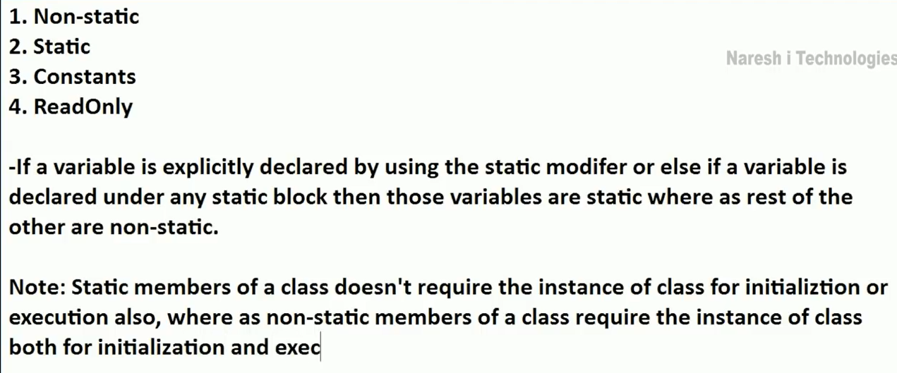

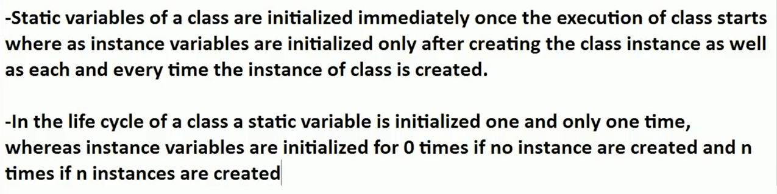



Constant :

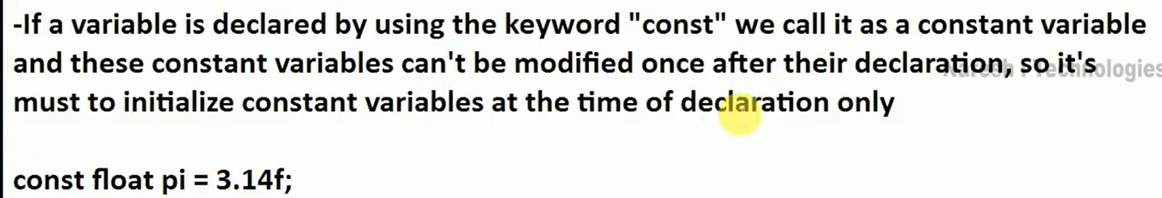

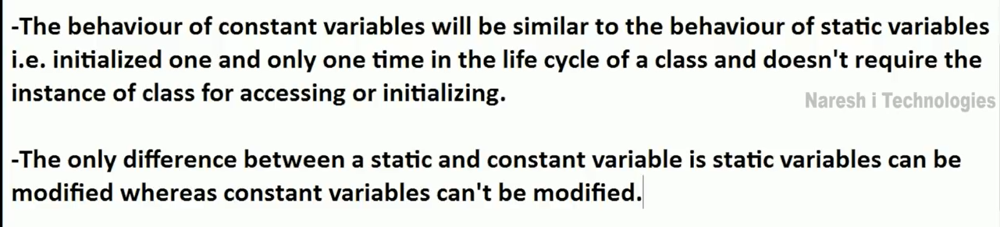

ReadOnly :

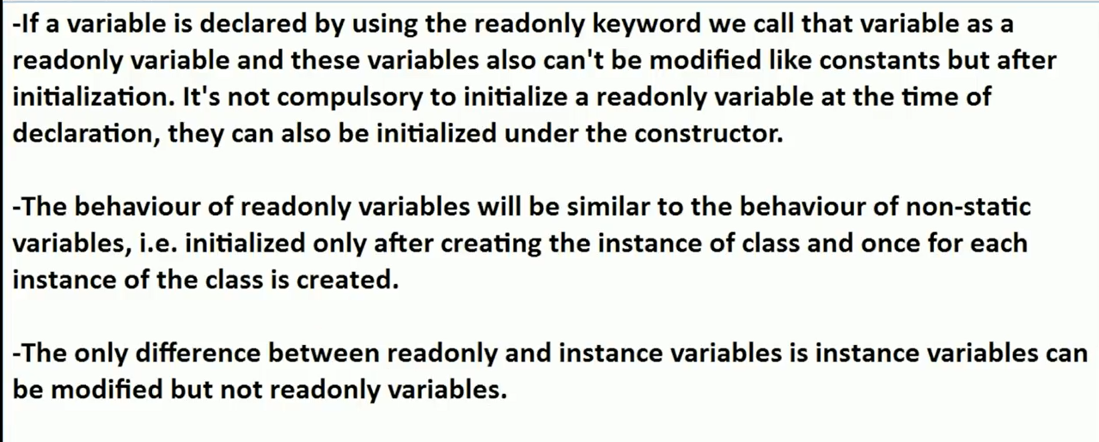



Introduction to Object Oriented Programming Concepts in C#

OOPs is a concept of modern programming language that allows programmers to organize entities and objects. Four key concepts of OOPs are abstraction, encapsulation, inheritance and polymorphism.

## OOP Features

Object Oriented Programming (OOP) is a programming model where programs are organized around objects and data

OOP allows decomposition of a problem into a number of entities called objects and then builds data and functions around these objects.

A class is a blueprint of an object that contains variables for storing data and functions to perform operations on the data.

A class will not occupy any memory space and hence it is only a logical representation of data.

To create a class, you simply use the keyword "class" followed by the class name:

Object

"An object is an instance of a class"

1. The software is divided into a number of small units called objects. The data and functions are built around these objects.
2. The data of the objects can be accessed only by the functions associated with that object.
3. The functions of one object can access the functions of another object.

Objects are the basic run-time entities of an object oriented system. They may represent a person, a place or any item that the program must handle.  
  
"An object is a software bundle of related variable and methods."  
  
A class will not occupy any memory space. Hence to work with the data represented by the class you must create a variable for the class, that is called an object.

When an object is created using the new operator, memory is allocated for the class in the heap, the object is called an instance and its starting address will be stored in the object in stack memory.

When an object is created without the new operator, memory will not be allocated in the heap, in other words an instance will not be created and the object in the stack contains the value **null**.

When an object contains null, then it is not possible to access the members of the class using that object.

## Abstraction

Abstraction is "To represent the essential feature without representing the background details."

Abstraction is the process of hiding the working style of an object, and showing the information of an object in an understandable manner.

Abstraction Class :

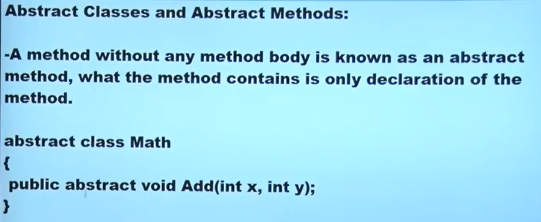

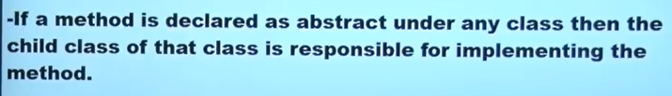

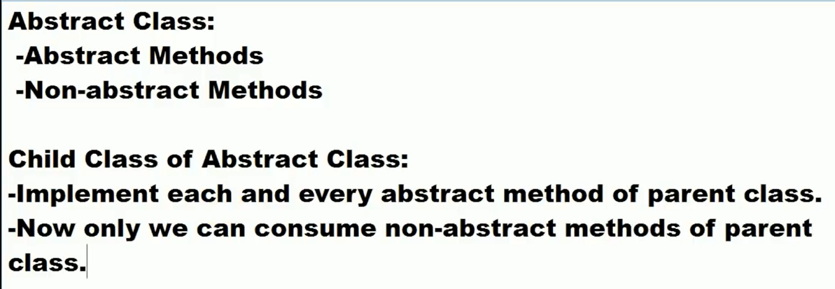

Abstract information (necessary and common information) for the object "Mobile Phone" is that it makes a call to any number and can send SMS.  
Abstraction means putting all the variables and methods in a class that are necessary.  
So that, for a mobile phone object you will have the abstract class as in the following,

abstract class MobilePhone {

public void Calling();

public void SendSMS();

}

public class Nokia1400: MobilePhone {}

public class Nokia2700: MobilePhone {

public void FMRadio();

public void MP3();

public void Camera();

}

public class BlackBerry: MobilePhone {

public void FMRadio();

public void MP3();

public void Camera();

public void Recording();

public void ReadAndSendEmails();

}

## Encapsulation

Wrapping up a data member and a method together into a single unit (in other words class) is called Encapsulation.

Encapsulation is like enclosing in a capsule. That is enclosing the related operations and data related to an object into that object.  
  
Encapsulation is like your bag in which you can keep your pen, book etc. It means this is the property of encapsulating members and functions.

class Bag {

book;

pen;

ReadBook();

}

Encapsulation is a technique used to protect the information in an object from another object.  
  
Hide the data for security such as making the variables private, and expose the property to access the private data that will be public.

So, when you access the property you can validate the data and set it.

Example1 :

class Demo {

private int _mark;

public int Mark {

get {

return _mark;

}

set {

if (_mark > 0) _mark = value;

else _mark = 0;

}

}

}

**Example 2**

**TV operation**

It is encapsulated with a cover and we can operate it with a remote and there is no need to open the TV to change the channel.  
Here everything is private except the remote, so that anyone can access the remote to operate and change the things in the TV.

## Inheritance

When a class includes a property of another class it is known as inheritance.

Inheritance is a process of object reusability.

For example, a child includes the properties of its parents.

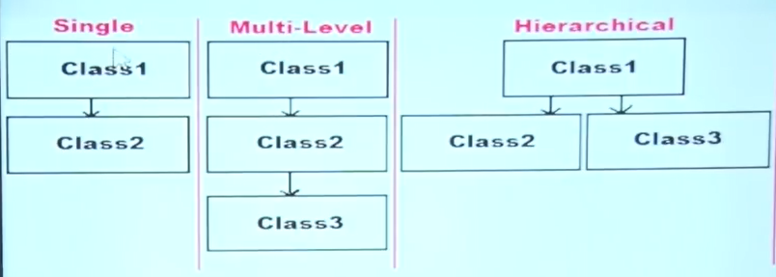

## Polymorphism

Polymorphism means one name, many forms.

One function behaves in different forms.

In other words, "Many forms of a single object is called Polymorphism."

**Example 1**

A teacher behaves students.

A teacher behaves his/her seniors.

Here teacher is an object but the attitude is different in different situations.

|  |  |
| --- | --- |
| **Abstraction** | **Encapsulation** |
| 1. Abstraction solves the problem at the design level. | 1. Encapsulation solves the problem in the implementation level. |
| 2. Abstraction hides unwanted data and provides relevant data. | 2. Encapsulation means hiding the code and data into a single unit to protect the data from the outside world. |
| 3. Abstraction lets you focus on what the object does instead of how it does it | 3. Encapsulation means hiding the internal details or mechanics of how an object does something. |
| 4. Abstraction: Outer layout, used in terms of design. For example: An external of a Mobile Phone, like it has a display screen and keypad buttons to dial a number. | 4. Encapsulation- Inner layout, used in terms of implementation.  For example: the internal details of a Mobile Phone, how the keypad button and display screen are connected with each other using circuits. |

**Use an example of a Mobile Phone**

You have a Mobile Phone, you can dial a number using keypad buttons. You don't even know how these are working internally. This is called Abstraction. You only have the information that is necessary to dial a number. But not internal working of the mobile.  
  
But how does the Mobile Phone work internally? How are the keypad buttons connected with internal circuit? That is called Encapsulation.

***Abstract Classes and Abstract Methods :***

* *A class under which we define abstract methods is known as an abstract class.*
* *A method without any method body is known as an abstract method, what the method contains is only declaration of the method.*
* *Public abstract void add(int x, int y);*
* *Note : to define a method or class as abstract we require to use the abstract keyword on them.*
* *Can’t create instance of abstract class.*

*Abstract class Math*

*{*

*Public abstract void add(int x, int y);*

*}*

* *If a method is declared as abstract under any class then the child class of that class is responsible for implementing the method without fail. - compulsory*
* *The concept of abstract method will be nearly similar to the concept of Method Overriding.*

*Class Class1*

*{*

*Public virtual void show () // Non abstract method*

*{*

*}*

*}*

*Class Class2:Class1*

*{*

*Public override void show() // method override optional -- can be re-implemented*

*{*

*-Re-Implementation*

*}*

*}*

*---------------------------------------*

*Abstract Class Class1*

*{*

*Public abstract void show () ;*

*}*

*Class Class2:Class1*

*{*

*Public override void show() // method implementation Compulsory*

*{*

*-Implementation*

*}*

*}*

*Abstract Class : contain*

*-Abstract Methods*

*-Non-abstract Methods*

*Child class of Abstract Class :*

*-Implement each and every abstract method of parent class.*

*-Now only we can consume non-abstract methods of parent class.*

*C# code compiled using CSC compiler or VB Code using VBC compiler into IL/partial compiled -- JIT - Machine langue/native code*

*code execute under the CLR called Managed code*

*other dll imported in project it does't controlled under CLR, this is called Unmanaged code.*

*Garbage collector is a background process which cleans unused managed resources.*

**Generics in c#**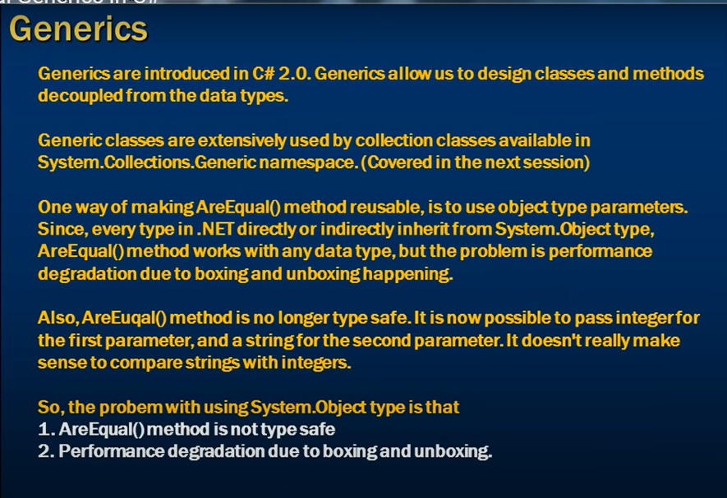

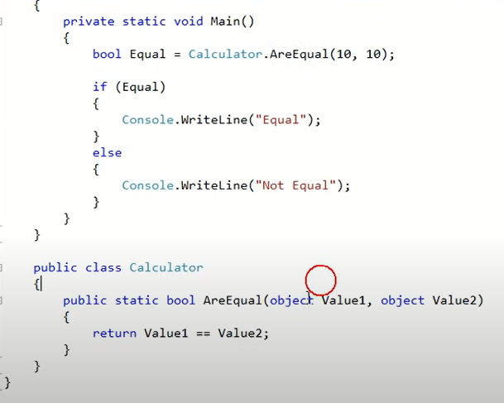

In the above example boxing and unboxing required therefore here performance issue arise. 10 – int – value type - value need to convert into reference type - object class.

**Generic Method :**

T - means any type of value.

we have to use Equals method instead of == sign.

Generic make your code type independent.

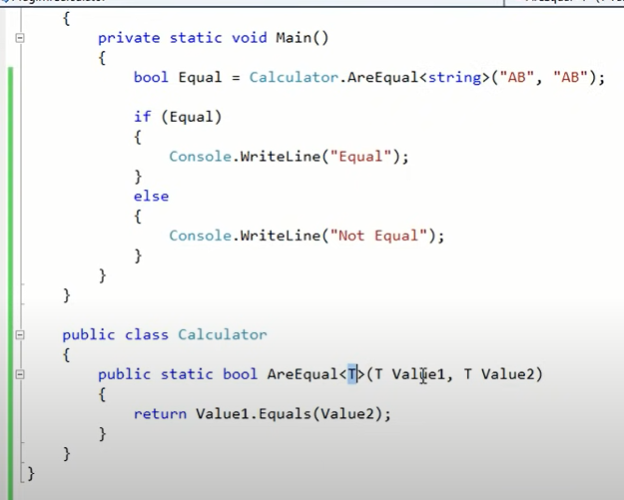

**Generic Class :**

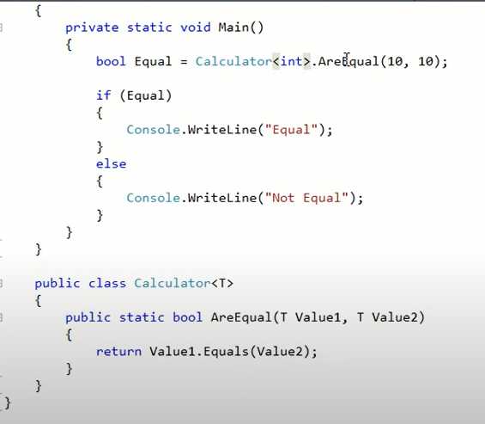

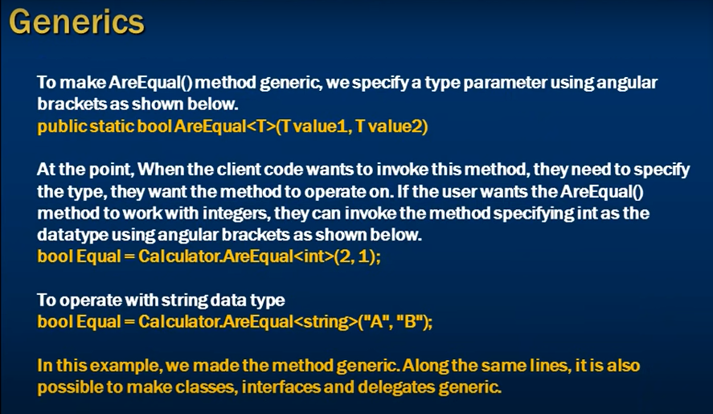

**Access modifiers in c#**

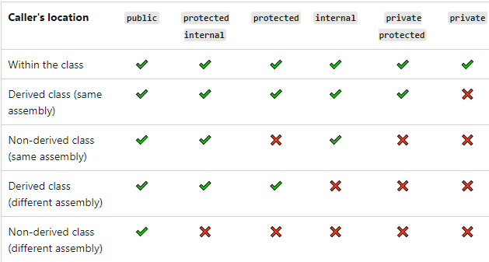

**Difference between method overloading and method overriding**

|  |  |  |
| --- | --- | --- |
| **Sr. No** | **Method Overloading** | **Method Overriding** |
| 1. | Creating more than one method or function having same name but different signatures or the parameters in the same class is called method overloading. | Creating a method in the derived class with the same signature as a method in the base class is called as method overriding |
| 2. | It is called the compile time polymorphism | It is called runtime polymorphism |
| 3. | It has the same method name but with different signatures or the parameters | It must have same method name as well as the signatures or the parameters. |
| 4. | Method overloading doesn’t need inheritance | Mehod overriding needs inheritance |
| 5. | Method overloading is possible in single class only | Method overriding needs hierachy level of the classes i.e. one parent class and other child class. |
| 6. | Access modifier can be any | Access modifier must be public. |
| 7. | Method overloading is also called early binding. | Method overriding is also called late binding. |

**Constructor in C#**

A constructor is a special method of the class which gets automatically invoked whenever an instance of the class is created. Constructor is responsible to initialize the variables of class.

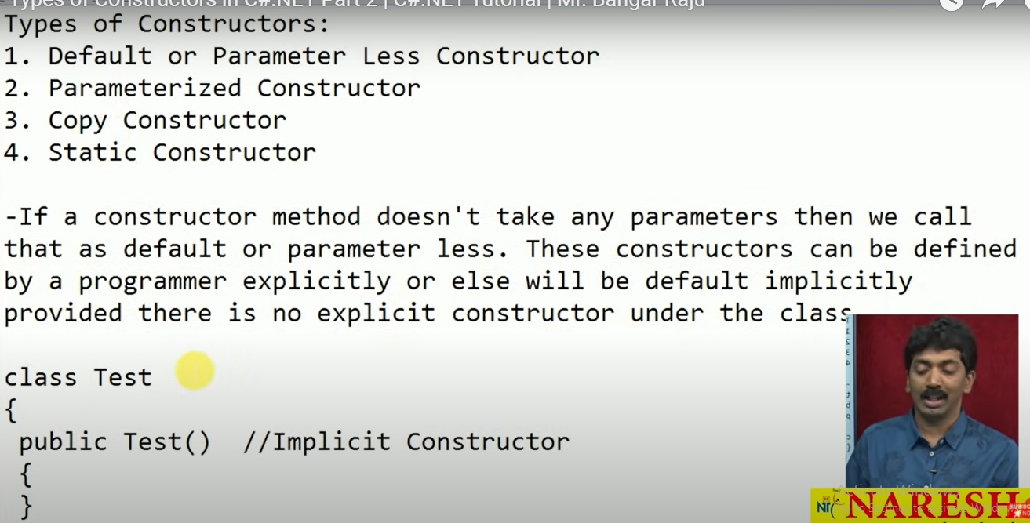

**Parameterized Constructor :** If a constructor method is defined with parameters we call that as parameterized constructor and these constructors can be defined by the programmers only but never can be defined implicitly.

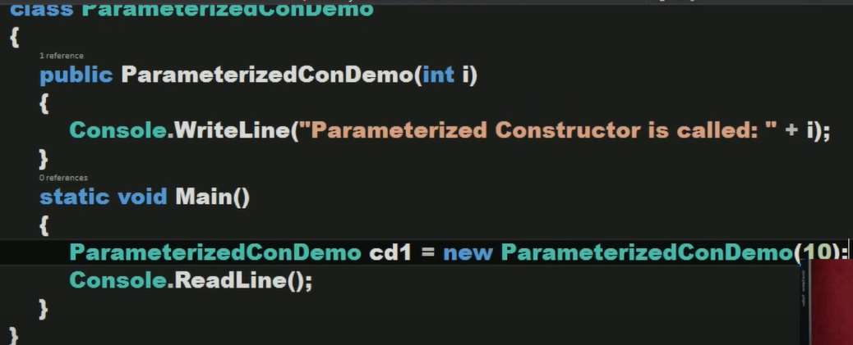

Copy Constructor : If we want to create multiple instances with the same values then we use these copy constructors, in a copy constructor the constructor takes the same class as a parameter to it.

internal class CopyConDemo

{

int X = 0;

public CopyConDemo(int i) // Parameterized Constructor

{

X = i;

}

public CopyConDemo(CopyConDemo obj) // Copy Constructor

{

X = obj.X;

//obj.Display();

}

public void Display()

{

Console.WriteLine("Value of x is " + X);

}

static void Main()

{

CopyConDemo cd1 = new CopyConDemo(10);

cd1.Display();

CopyConDemo cd2 = new CopyConDemo(cd1);

cd2.Display();

}

}

**Static Constructor :** If a constructor is explicitly declared by using static modifier we call that as Static Constructor. All the constructors we have defined till now are non-static or instance constructors.

If a class contains any static variables then only implicitly static constructors will be present or else we need to define them explicitly whereas non-static constructors will be implicitly defined in every class (except static class) provided we did not define them explicitly.

Static constructor are responsible in initializing static variables and these constructor never called explicitly.

Static constructors can’t be parameterized so overloading constructors is not possible.

class Test

{

static Test() // Static constructor defined explicityly

{

}

public Test() // Implicit default constructor

{

}

}

**Use of Async and Await keyword.**

The async keyword turns a method into an async method, which allows you to use the await keyword in its body. When the await keyword is applied, it suspends the calling method and yields control back to its caller until the awaited task is complete await can only be used inside an async method.

**IEnumerable vs IQueryable**

Both IEnumerable and IQueryable are forward collection. Querying data from a database, IEnumerable execute a select query on the server side, load data in-memory on a client-side and then filter data. Querying data from a database, IQueryable execute the select query on the server side with all filters.

Following are some of the important differences between ref and out keywords.

| **Sr. No.** | **Key** | **ref keyword** | **out keyword** |
| --- | --- | --- | --- |
| 1 | Purpose | ref keyword is used when a called method has to update the passed parameter. | out keyword is used when a called method has to update multiple parameter passed. |
| 2 | Direction | ref keyword is used to pass data in bi-directional way. | out keyword is used to get data in uni-directional way. |
| 3 | Initialization | Before passing a variable as ref, it is required to be initialized otherwise compiler will throw error. | No need to initialize variable if out keyword is used. |
| 4 | Initialization | In called method, it is not required to initialize the parameter passed as ref. | In called method, it is required to initialize the parameter passed as out. |

|  |  |
| --- | --- |
| Abstract Class | Interface |
| It can contain abstract and non-abstract methods. | It can contain only abstract methods. |
| It contains both declaration and definition part. | It contains only a declaration part. |
| Multiple inheritance is not achieved by abstract class. | Multiple inheritance is achieved by interface. |
| It contain [constructor](https://www.geeksforgeeks.org/c-sharp-constructors/). | It does not contain [constructor](https://www.geeksforgeeks.org/c-sharp-constructors/). |
| It can contain static members. | It does not contain static members. |
| It can contain different types of access modifiers like public, private, protected etc. | It only contains public access modifier because everything in the interface is public. |
| The performance of an abstract class is fast. | The performance of interface is slow because it requires time to search actual method in the corresponding class. |
| It is used to implement the core identity of class. | It is used to implement peripheral abilities of class. |
| A class can only use one abstract class. | A class can use multiple interface. |
| If many implementations are of the same kind and use common behavior, then it is superior to use abstract class. | If many implementations only share methods, then it is superior to use Interface. |
| Abstract class can contain methods, fields, constants, etc. | Interface can only contains methods, properties, indexers, events. |
| It can be fully, partially or not implemented. | It should be fully implemented. |

**How to swap value without using temporary variable ?**

static void Main(string[] args)

{

int a = 10; int b = 20;

Console.WriteLine("Value before swap of a={0}, Value of b= {1}", a, b);

a = a + b; //30

b = a - b; //10

a = a - b; //20

Console.WriteLine("Value after swap with temporary variable of a={0}, Value of b= {1}", a,b);

Console.ReadKey();

}

**#### MVC**

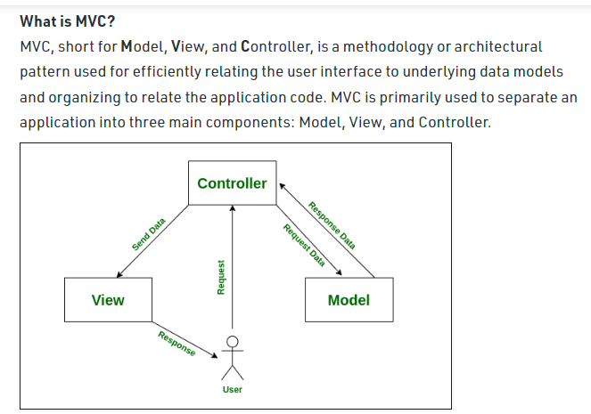

OutputCache Attribute in MVC : is used to cache the content returned by a controller action method, so that, the same content does not need to be generated each and every time the same controller action is invoked.

[OutputCache(Duration=10)]

Public ActionResult Index()

{

Return View(db.Employees.ToList());

}

Action filters are attributes that can be applied either on a controller action method or on a controller. When applied at the controller level they are applicable for all action within that controller. Action filters allow us to add, pre and post processing login to an action method. This means, they allow us to modify the way in which an action is executed.

**The ASP.NET MVC framework supports four different types of filters:**

* Authorization filters – Implements the IAuthorizationFilter attribute.
* Action filters – Implements the IActionFilter attribute.
* Result filters – Implements the IResultFilter attribute.
* Exception filters – Implements the IExceptionFilter attribute.

**Name a few commonly used Action Filters ?**

1.Authorize

2.ChildActionOnly

3.HandleError

4.OutputCache

5.RequireHttps

6.ValidateInput

7.ValidateAntiForgeryToken

# Difference between ViewData, ViewBag and TempData?

1.Viewdata - It lies only during the current request.

2.ViewBag - It lies only during the current request.

3.TempData - TempData only works during the current and subsequent request

**ViewBag and ViewData** are used to communicate between controller and corresponding view.

**ViewData** is a dictionary object while **ViewBag** is a dynamic property (a new C# 4.0 feature).ViewData being a dictionary object is accessible using strings as keys and also requires typecasting for complex types. On the other hand, ViewBag doesn’t have typecasting and null checks.

**TempData** is also a dictionary object that stays for the time of an HTTP Request. So, Tempdata can be used to maintain data between redirects i.e from one controller to the other controller.

Note that TempData is only work during the current and subsequent request. It is generally used to store one time messages. With the help of the TempData.Keep() method we can keep value in TempData object after request completion.

**Explain the life cycle of MVC application?**

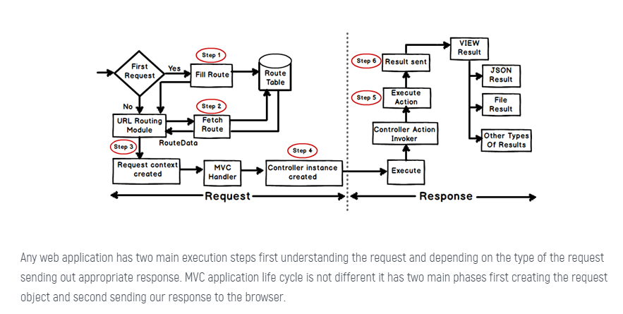

**Difference between razor and aspx view engine in mvc.**

Razor Engine prevents Cross-Site Scripting Attacks, in other words it encodes the script or HTML tags like <,> before rendering to view. ASPX Engine does not prevent Cross-Site Scripting Attacks, in other words any script saved in the database will be fired while rendering the page.

Razor Engine is little bit slow as compared to Webform Engine.

**Namespace**:-

* The Namespace for ASPX/Web Form engine is **System.Web.mvc.Web Form** view engine.
* The Namespace for Razor view engine is **System.Web.Razor**

**Layout/master page**:-

* We can use master page with ASPX view Engine.
* We can use Layouts with Razor View engine.

**File extensions**:-

* The file extensions used with **ASPX** view engine are  same as asp.net web forms. Ex. **.aspx**extension is used for views,**.ascx** extension is used for partial views ,WebUserControl and editor template and **.master** extension is used for master page layouts.
* The file extensions used with Razor view engine are **.Cshtml** (Razor with C#) or **.VBhtml** (Razor with VB).

**Symbols**:-

* **<% ..%>** character is used for writing the **ASPX** view engine code.                                                   **ex.**  <%Html.ActionLink ("Login", "login_page")%>
* The character **@**  uses with Razor view engine.                                                                            **ex.** @Html.ActionLink ("SignUp", "Reg_page")

**Look and Feel**:-

* ASPX view Engine support design mode, means you can see your page look and feel without running the mvc application.
* Razor view engine does not support design mode in visual studio,means you can't see your page without running the application.

**Syntax**:-

* ASPX/Web Form syntax are not easy to learn.
* But **Razor** syntax are easy to learn and clean than **ASPX** view engine.

**What is the use of bundling and minification in MVC?**

Bundling and Minification are two performance improvement technique that improve the request load time of the application. Most of the current major browsers limit the number of simultaneous connections per hostname to six. It means that at a time, all the additional requests will be queued by the browser.

**Bundling** allows us to load the bunch of static files from the server in a single HTTP request. MVC provides inbuild feature to bundle multiple files into a single, file which in turn improves the page load performance because of fewer HTTP request.

**Minification** is another such performance improvement technique in which it optimize the javascript, css code by shortening the variables names, removing unnecessary white spaces, line breaks, comments etc. This is turn reduce the file size and helps the application to load faster.

**#### Entity Framework**

Entities are mapped to database tables and object relational mapping (ORM) tools like Entity Framework, nHibernate etc. are used to retrieve and save data.

Business objects contain both state (data) and behavior, that is logic specific to the business.

**##### Web API**

## PUT vs POST verbs Difference.

## Can we insert data using Put verb ? Ans : yes

In a typical [REST architecture](https://www.baeldung.com/cs/rest-architecture), a client sends requests in the form of HTTP methods to the server to create, retrieve, modify, or destroy resources. While we can use both PUT and POST to create resources, there are significant differences between them in terms of their intended applications.

According to the [RFC 2616](https://tools.ietf.org/html/rfc2616) standard, the POST method should be used to request that the server accept the enclosed entity as a subordinate of the existing resource identified by the Request-URI. This means **the POST method call will create a child resource** under a collection of resources.

Conversely, the PUT method should be used to request that the server store the enclosed entity under the provided Request-URI. If the Request-URI points to an existing resource on the server, the supplied entity will be considered a modified version of the existing resource. Therefore, **the PUT method call will either create a new resource or update an existing one**.

**Another important difference between the methods is that PUT is an idempotent method, while POST isn't. For instance, calling the PUT method multiple times will either create or update the same resource. In contrast, multiple POST requests will lead to the creation of the same resource multiple times.**

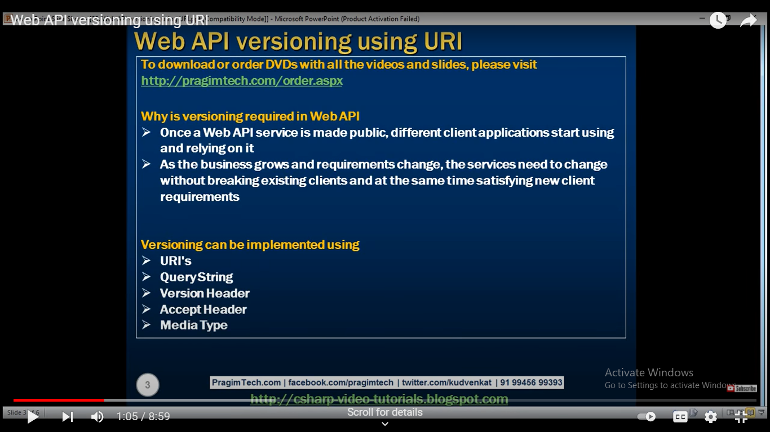

How to maintain version in web API ? /Web API Versioning

1. Using URI
2. Using QueryString
3. Using Custom Header
4. Using Accept Header
5. Using Custom Media Types

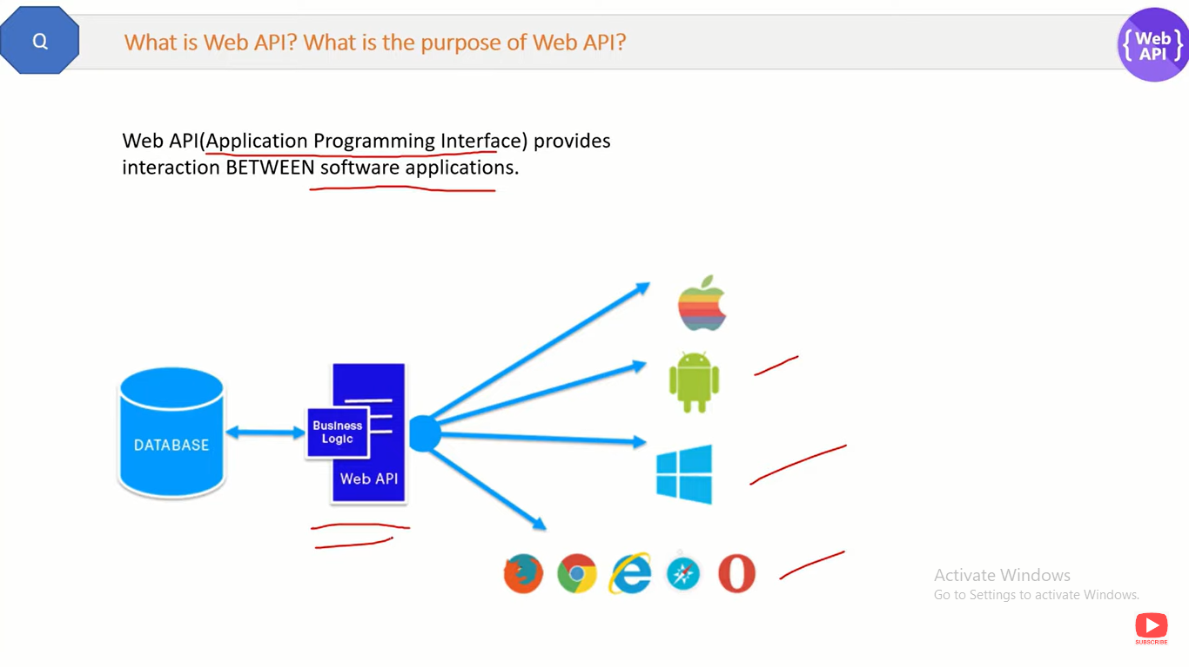

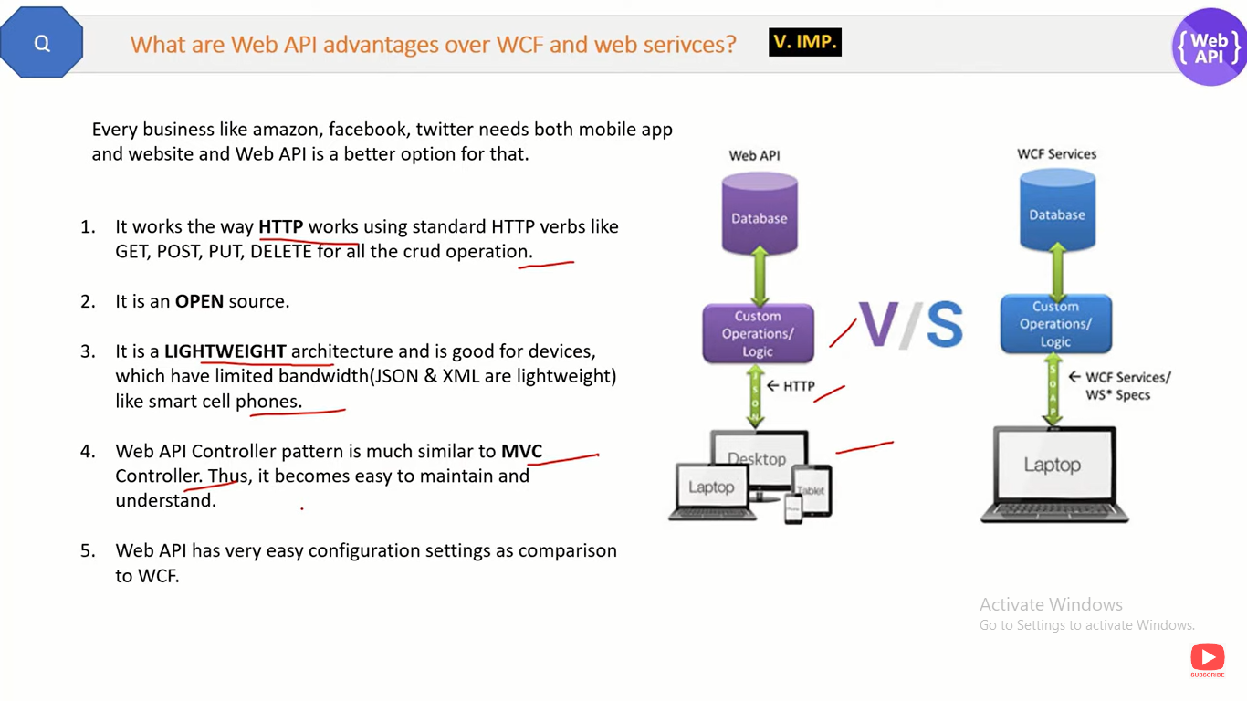

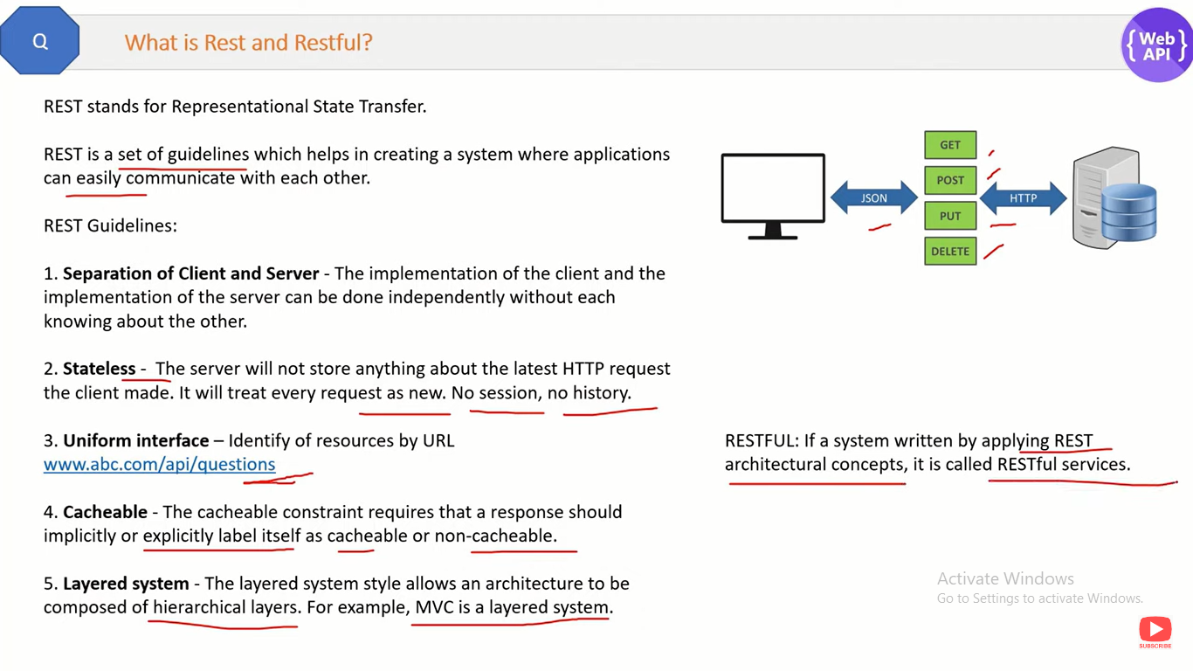

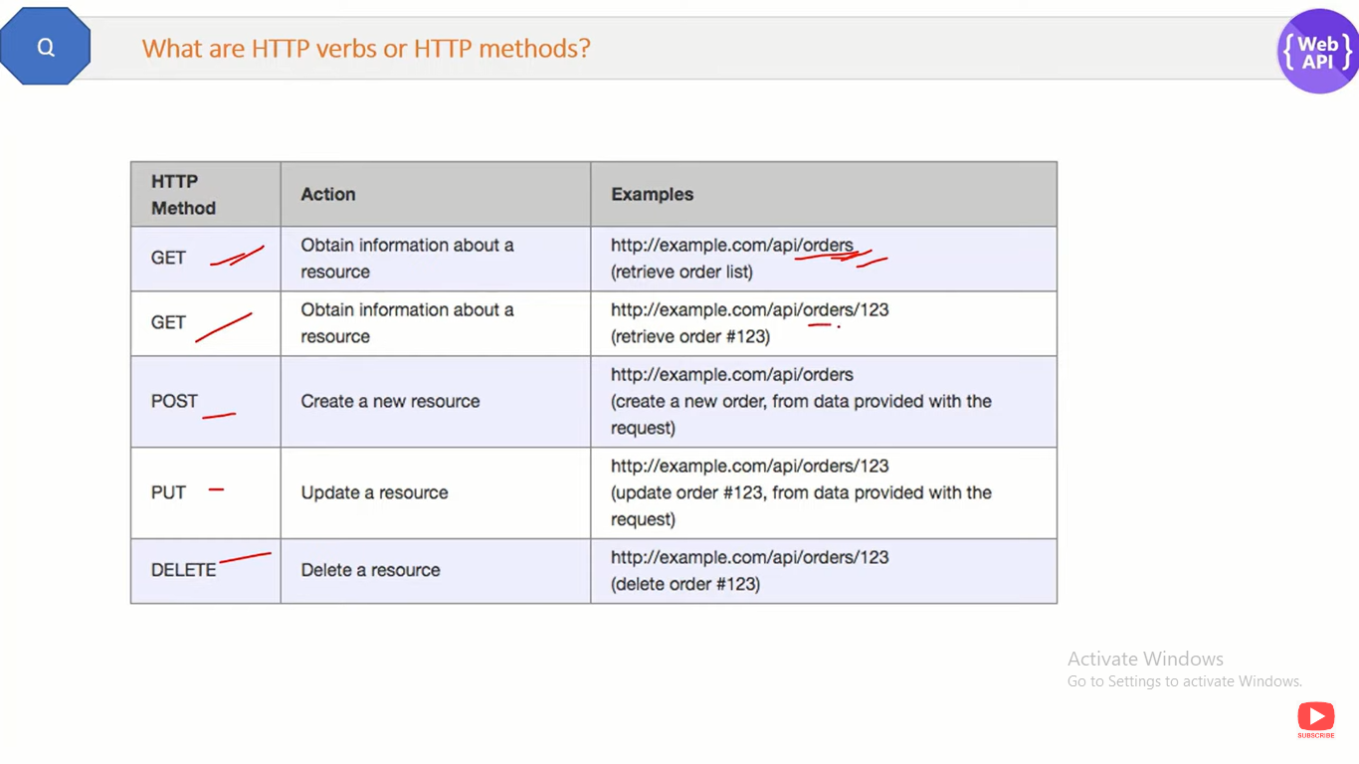

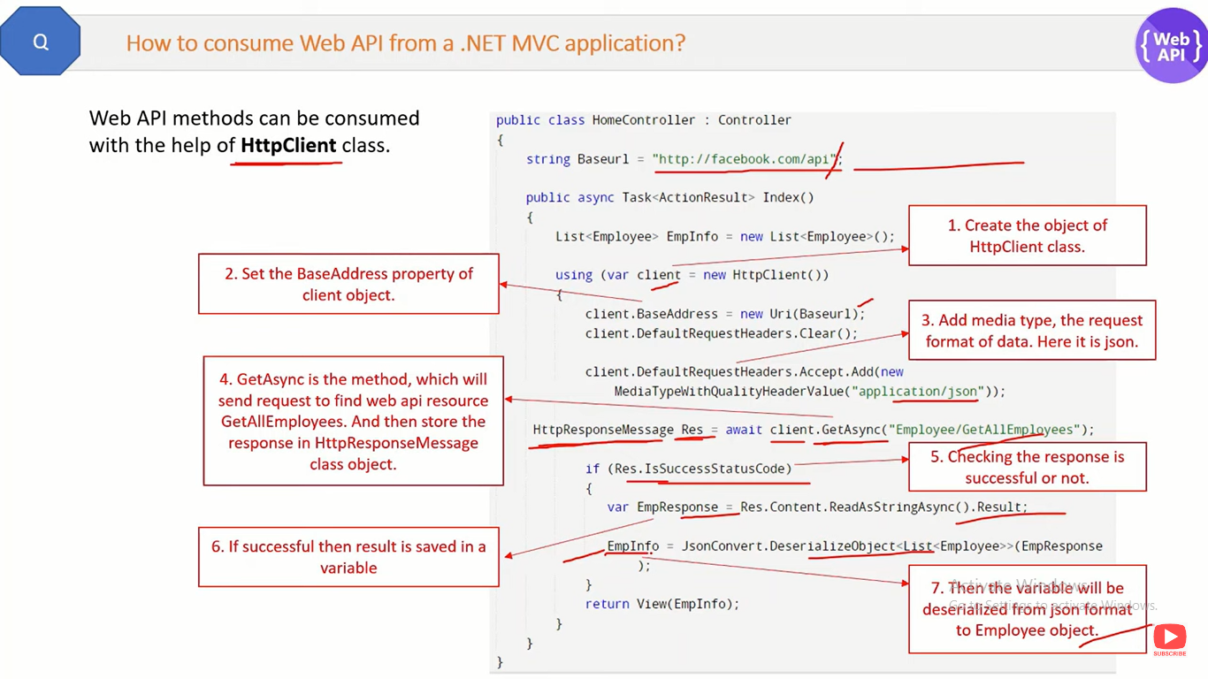

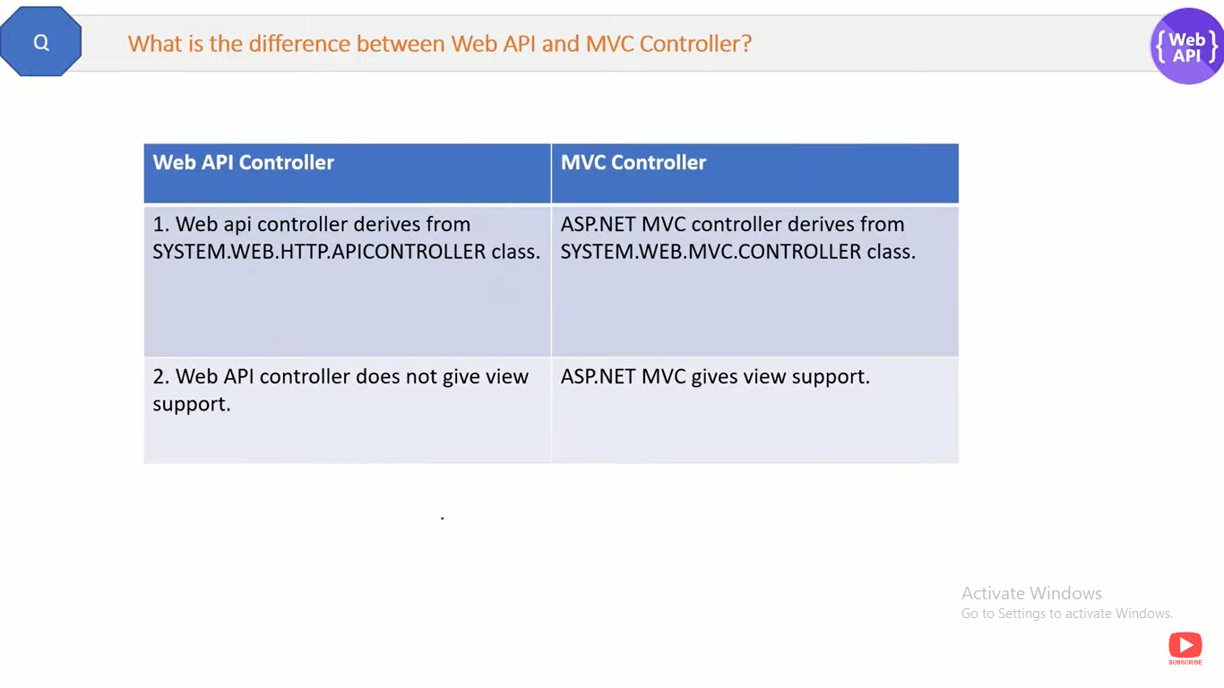

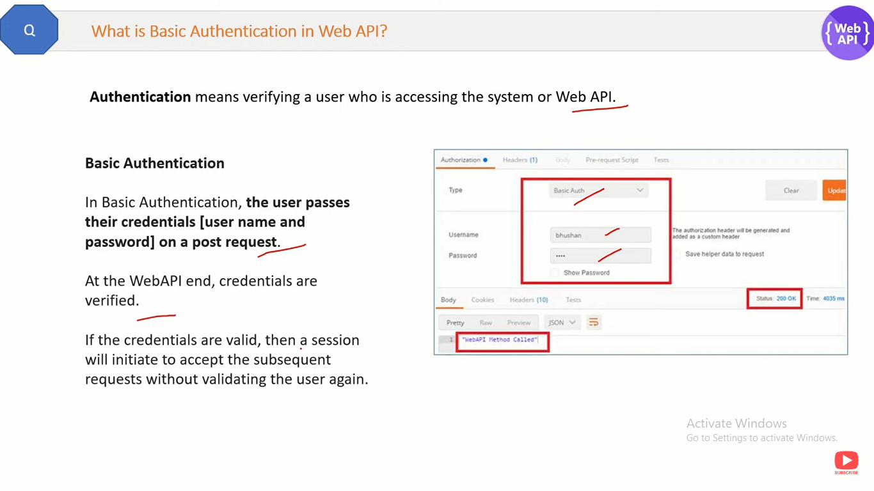

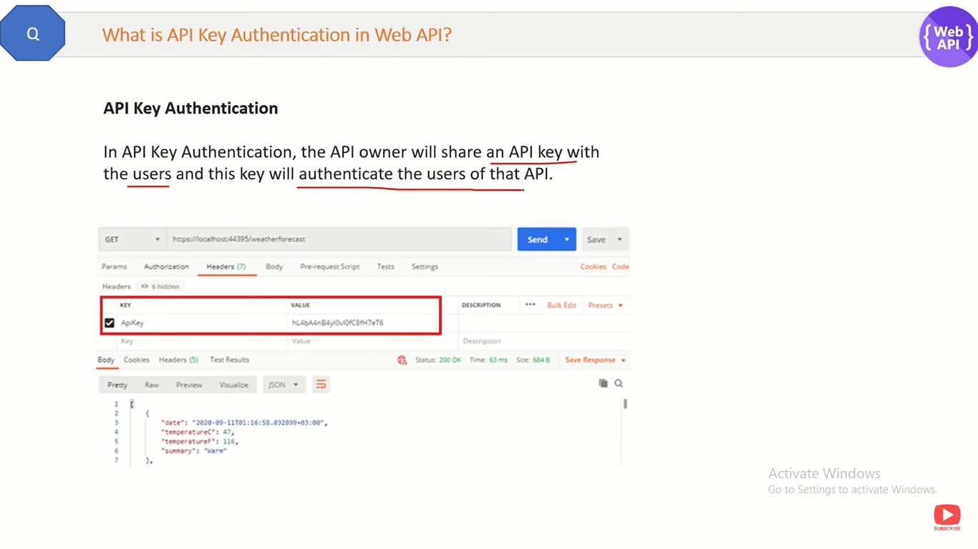

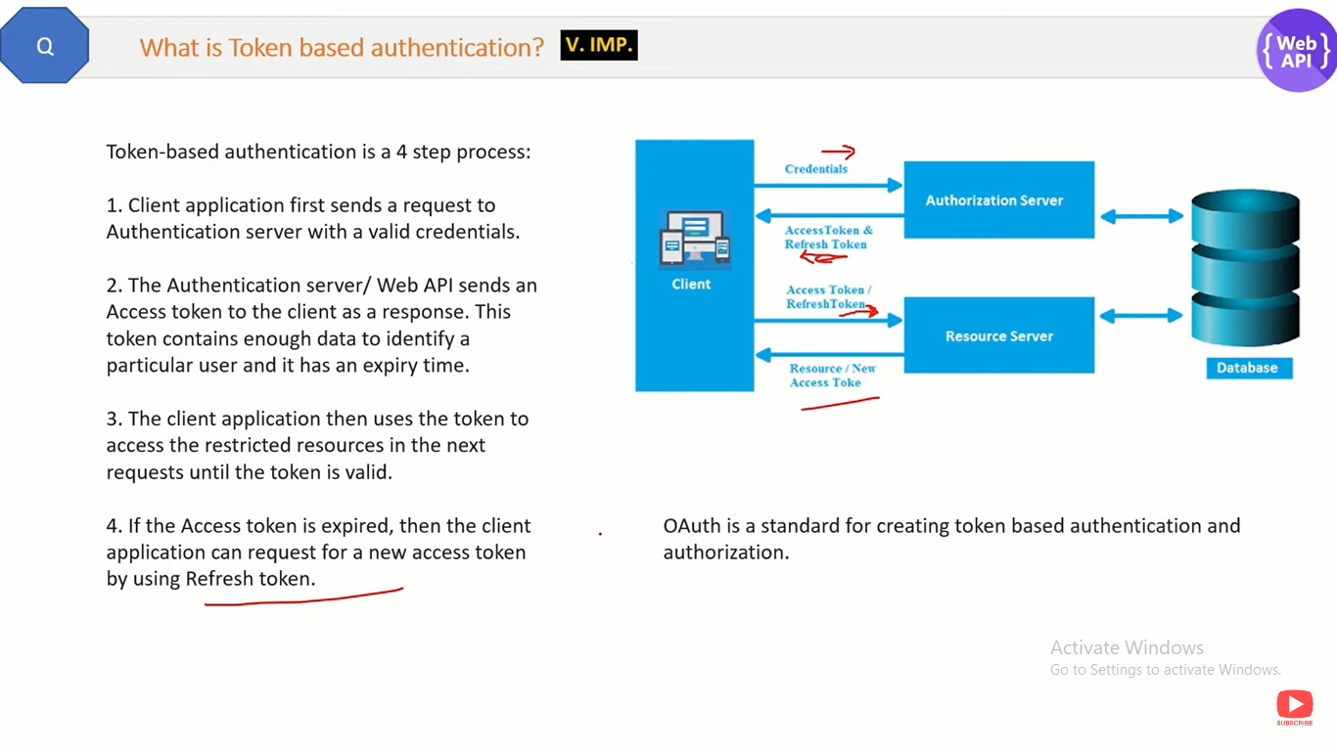

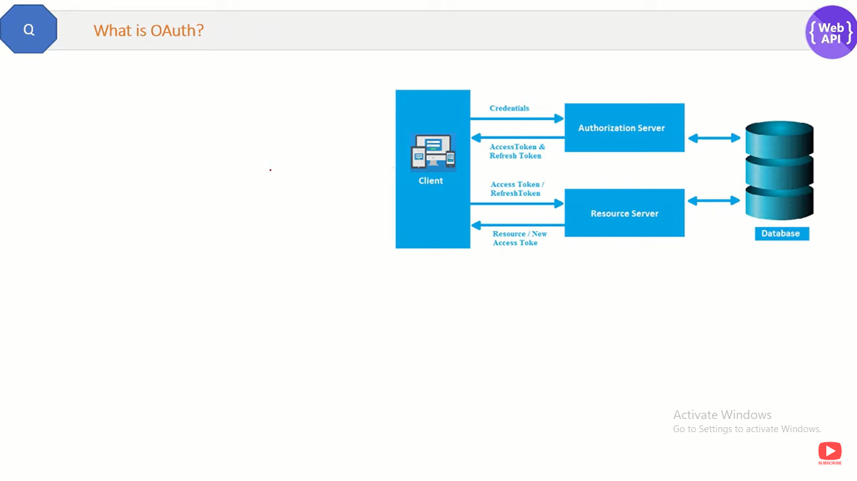

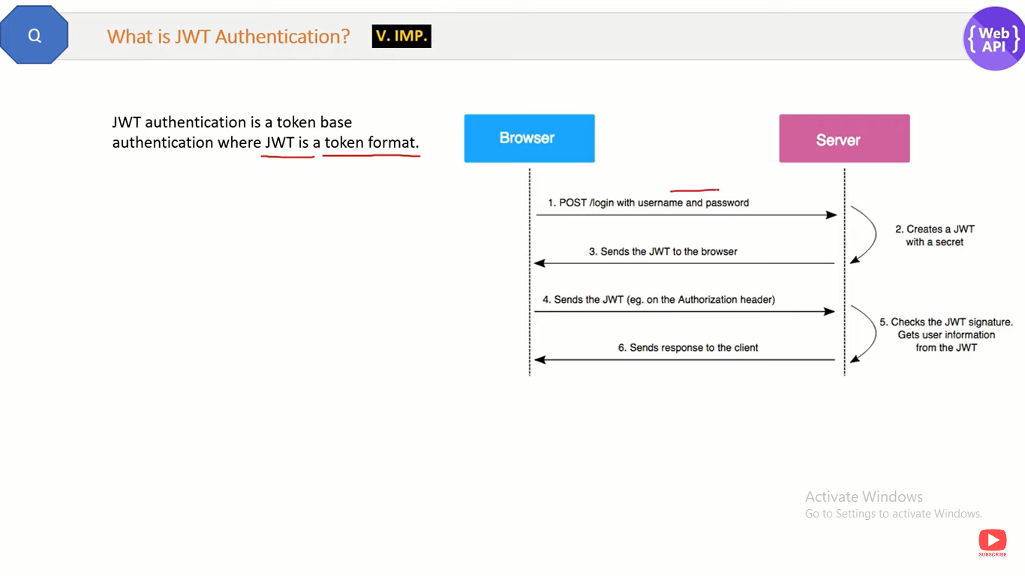

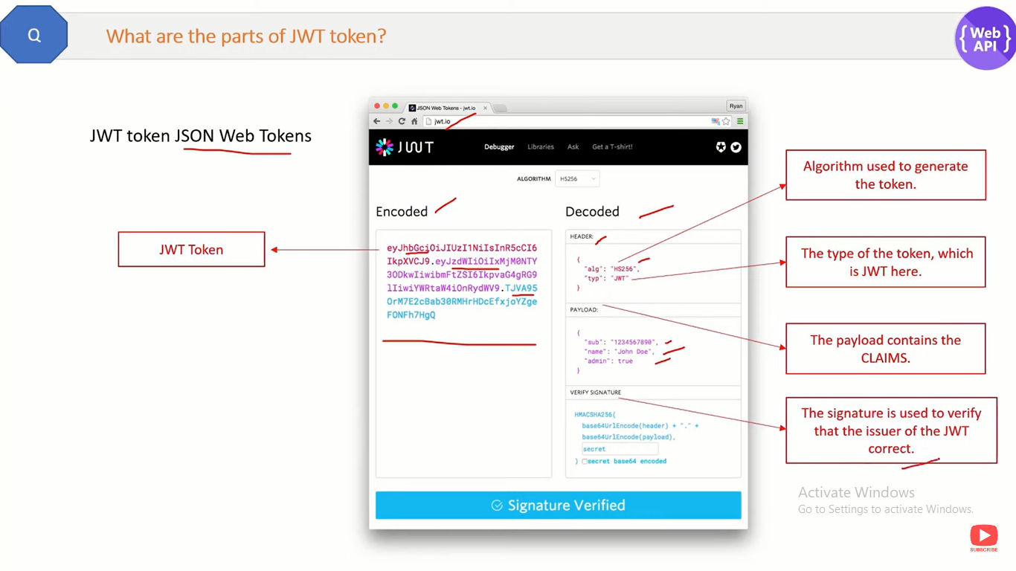

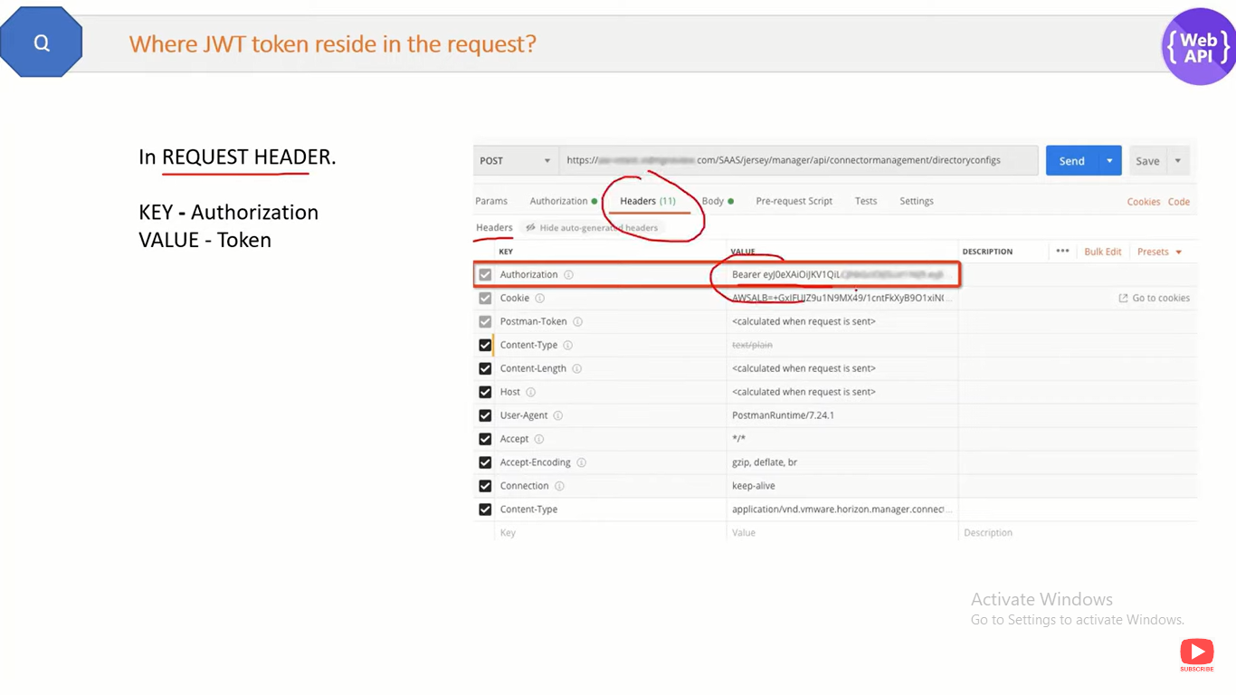

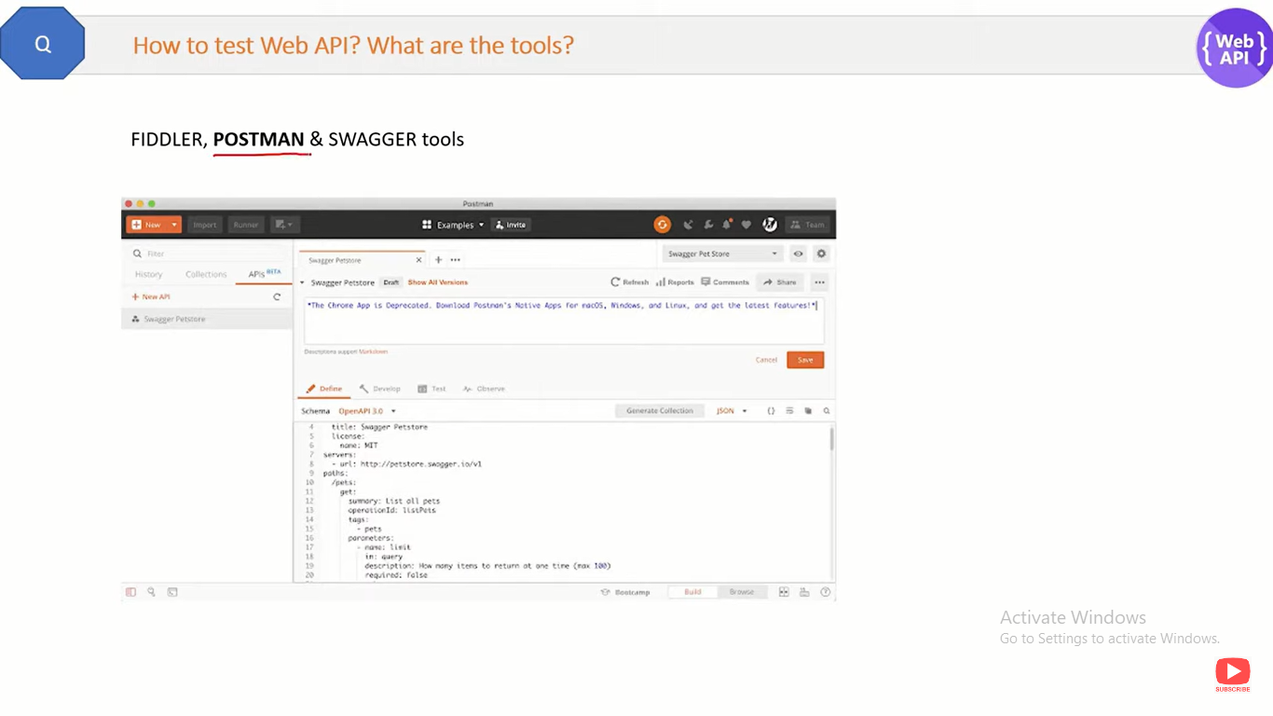

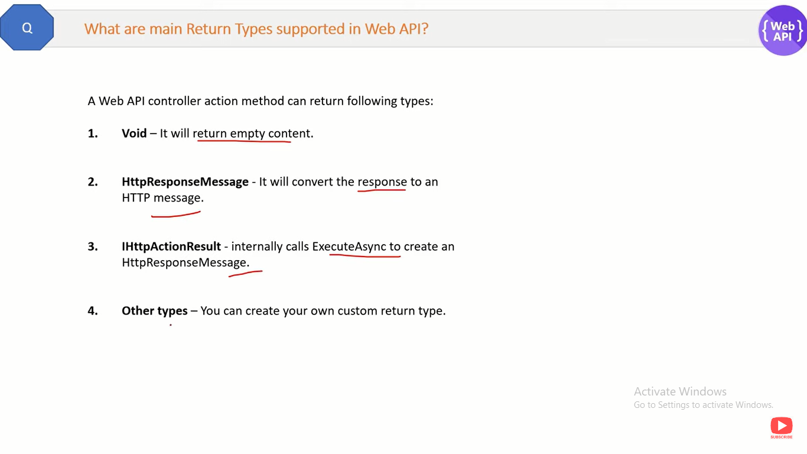

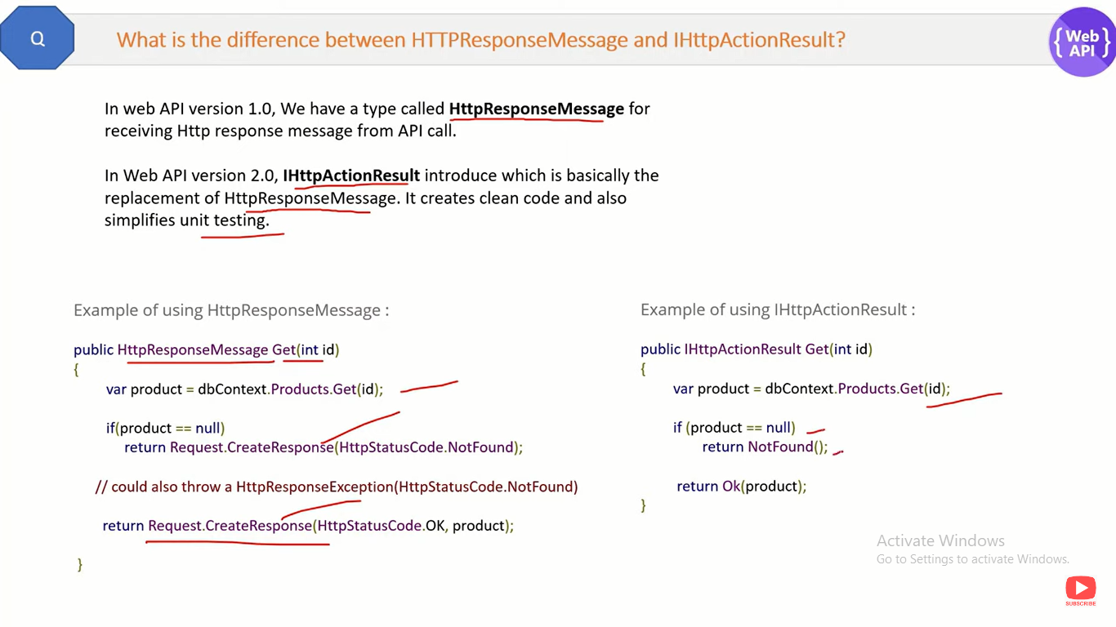

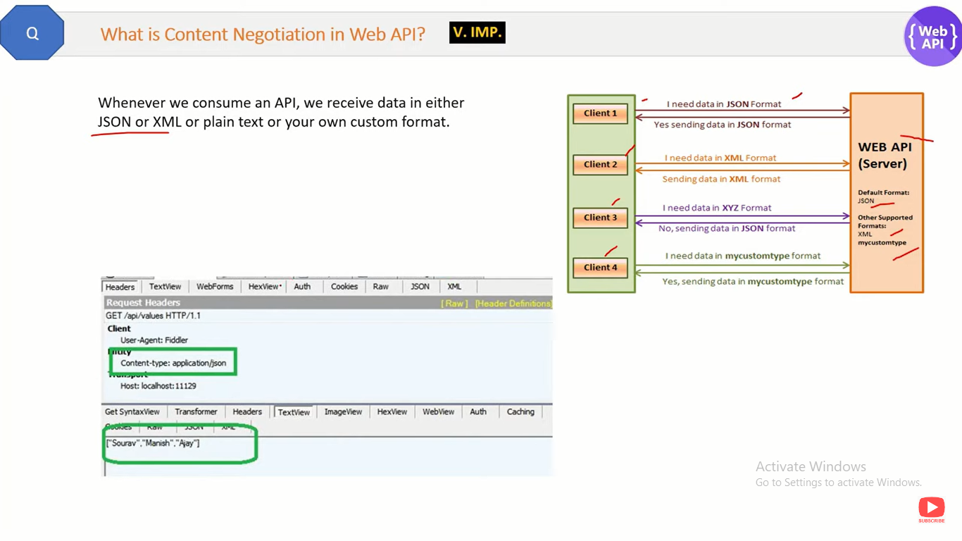

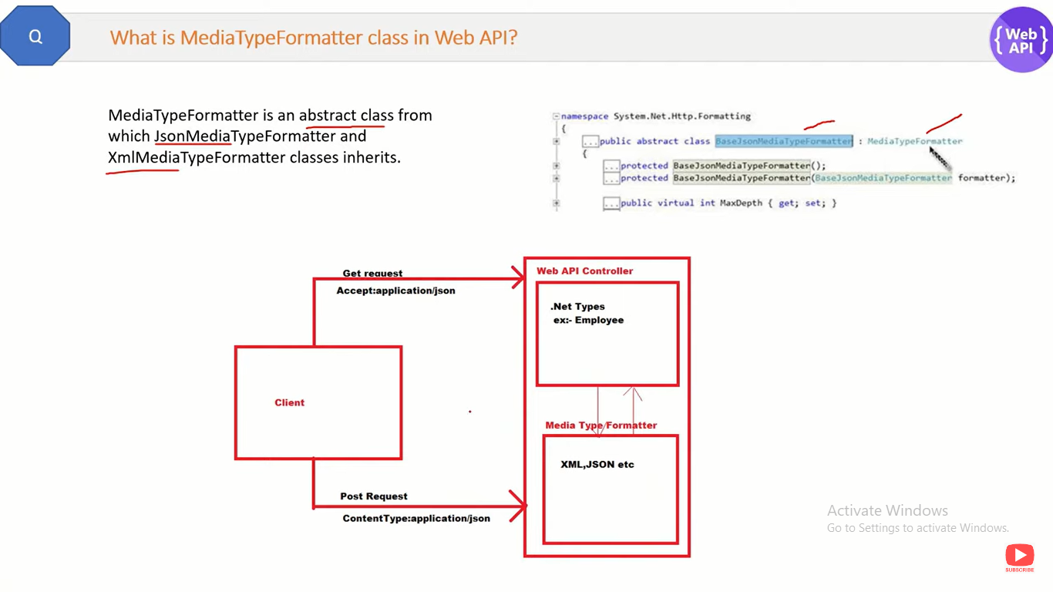

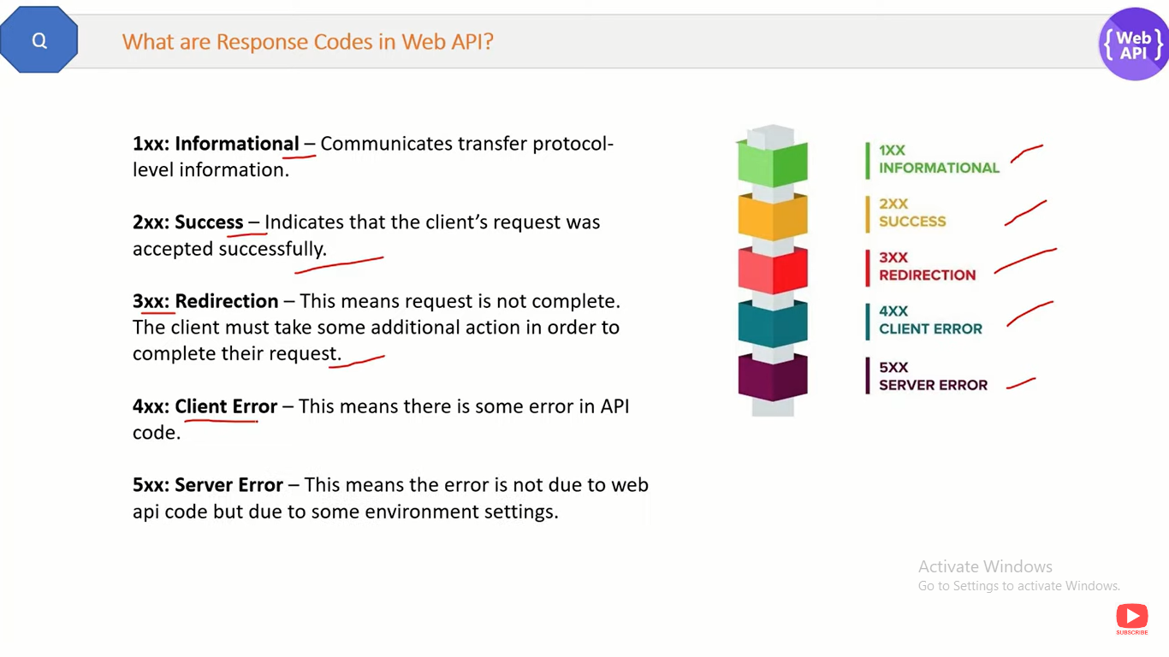

**##### SQL**

**Difference between identity and scope_identity.**

SCOPE_IDENTITY and @@IDENTITY return the last identity values that are generated in any table in the current session. However, **SCOPE_IDENTITY returns values inserted only within the current scope; @@IDENTITY is not limited to a specific scope**.

# ACID Properties in DBMS

**A transaction is a single logical unit of work that accesses and possibly modifies the contents of a database. Transactions access data using read and write operations.**

**In order to maintain consistency in a database, before and after the transaction, certain properties followed. These are called ACID properties.**

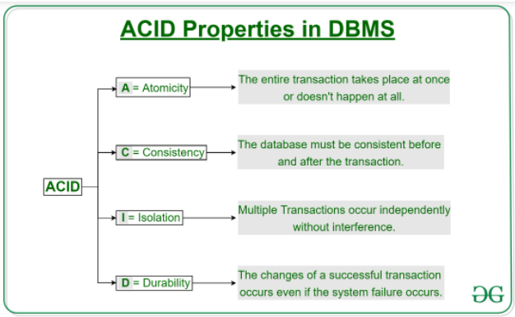

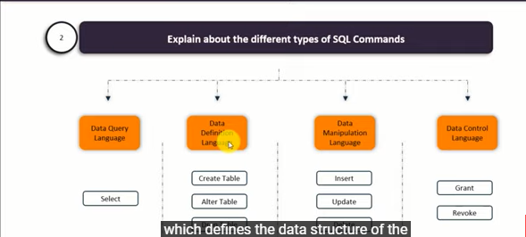

**Constraint :**

Default : to set default value for a column when no value is specified.

Unique : Unique constraint ensures that all values in a column are different. NULL allowed but only one time.

Not NULL : ensures that a column can’t have a NULL value.

Primary Key : A combination of a Not NULL and Unique. Uniquely identifies each row in a table.

Check : Ensures that the value in a column satisfies a specific condition.

Foreign key : Prevents actions that would destroy links between tables.

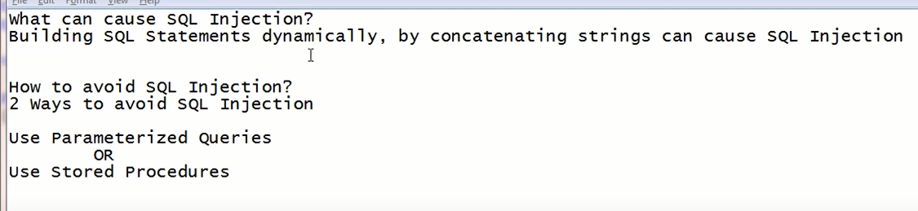

**Function vs Stored Procedures**

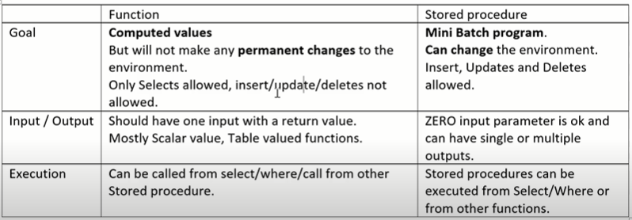

**Stored Procedure Benefits.**

1. They avoid SQL Injection
2. They reduce network traffic between web server and database server (you just need to send SP name to DB server, you don’t have to send lengthy SQL statement)
3. You can reuse SP on multiple pages without having to duplicate.
4. Increase Performance – SP can have execution plan for certain period of time but SQL query need to generate execute plain every time while calling.

**Trigger**

Trigger nothing but the small piece of logic which you want to execute when certain events like Insert, update, delete happens then you want to go and execute some logic.

e.g : Create trigger trg_datamanipulation

on tblCustomer

after Insert/ Update /Delete

As

Begin

Insert into tblAudit(LastUpdated) values (getdate())

End

**What are types of triggers ?**

There are two types **After trigger** and **Instead OF trigger**.

After trigger – After event has happened logic is executed.

Instead OF trigger- Instead of the event the logic is executed.

**Explain transactions and how to implement it ?**

Transaction helps to implement series of activity treat as one single unit. Either everything is successful and or everything rollbacks.

e.g- begin try

begin tran

* + – Insert, update, delete, select

commit tran

end try

begin catch

rollback

end catch

**How to create table structure from existing table without data?**

SELECT * into Employees_New FROM Employees_Existing WHERE 1=2

**How to remove duplicate records from Table?**

with CTE_ABC

as

(select * , ROW_NUMBER() over (partition by id,name order by id) as SrNo from Table_1 )

delete from CTE_ABC where SrNo>1

**How would you find the 2nd highest salary from the table ?**

* **If duplicate values available of salary**

with CTE_ABC

as

(select distinct *,ROW_NUMBER() over (order by (select distinct top 1 salary from Employees) desc) as SrNo from Employees )

select top 1 * from CTE_ABC where SrNo=2

or **– if unique values**

with CTE_ABC

as

(select ROW_NUMBER() over ( order by salary desc) as SrNo, * from Employee )

select top 1 * from CTE_ABC where SrNo=2

**or**

select * from (

select ROW_NUMBER() over (order by salary desc) as SrNo, * from Employees

) as tbl where SrNo =2

select max(salary) from [dbo].[Employee] where salary not in (select max(salary) from [dbo].[Employee])

select max(salary) from [dbo].[Employee] where salary < (select max(salary) from [dbo].[Employee])

select top 1 * from [dbo].[Employees]

where id not in(select top 1 id from Employees order by salary desc)

order by salary desc

**Third Highest Salary**

* **If duplicate values available of salary**

with CTE_ABC

as

(select distinct *,ROW_NUMBER() over (order by (select distinct top 1 salary from Employees) desc) as SrNo from Employees)

select top 1 * from CTE_ABC where SrNo=3

**or – if unique values**

with CTE_ABC

as

(select ROW_NUMBER() over ( order by salary desc) as SrNo, * from Employee )

select top 1 * from CTE_ABC where SrNo=3

or

select * from (

select ROW_NUMBER() over (order by salary desc) as SrNo, * from Employees

) as tbl where SrNo =3

Or

select top 1 * from [dbo].[Employees]

where id not in(select top 2 id from Employees order by salary desc)

order by salary desc

**What do you understand by Normalizatin and De-normalization?**

Normalization is a database design technique to remove redundant data.

Normalization is implemented by splitting tables in to two, one with reference data (master table) and other transaction data.

1st normal form : A table is in first normal form when **the columns have Atomic values**. **It should not have repeating groups.**

e.g- Name – Santosh, Balu, Patil – FirstName-Santosh, MiddleName-Balu, Surname-Patil

2nd normal form : First normal form should be satisfied. **All non-key columns should be fully dependent on the primary key.**

e.g – CountryName used in transaction table instead of create master for country and use countryId as a foreign key in transaction table.

3rd normal form : All 1st and 2nd normal form should be satisfied. **No transient dependency should be present.**

e.g – product name and price should not present in transaction table, create master table product master use product id as foreign key in transaction table.

In short (APT) – Atomic, Partial Dependency, Transient.

**Denormalization is a database design technique to improve search performance.**

**Denormalization is the process of adding redundant data to speed up complex queries.**

OLTP (Online Transaction Process) – (insert, update, delete tran.) OLTP Normalization avoids redundant and we follow normalization design (1st, 2nd , 3rd normal).

OLAP (Online Analytic Process) – (fetch data for reports) OLAP Denormalization improve search performance and we follow denormalization design.

**Difference between Primary and Unique key?**

Primary key – NULL not allowed, only one primary key on a table.

Unique key – Null allowed but single, May be multiple unique key on a table.

Difference between Char and Varchar?

Char : fixed length, just store English character, Char 1 character = 1 byte

NChar : For multilingual language (N stands for Unicode), NChar 1 Character = 2 bytes

Varchar : variable length, just store English character.

**Common Table Expression (CTE) :** A CTE is a temporary result set, that can be referenced within a select, Insert, Update or Delete statement, that immediately follows the CTE.

--Syntax

With CTE_Name (Column1, Column2, …) – column name is optional, ref to inner query col_name

As

(CTE_query)

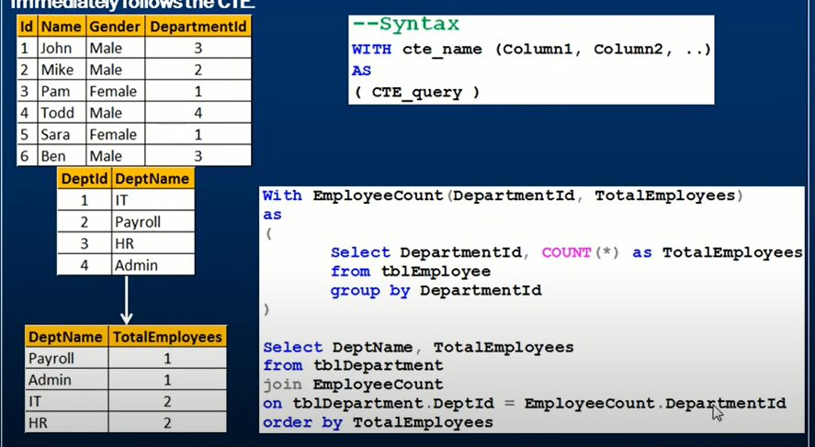

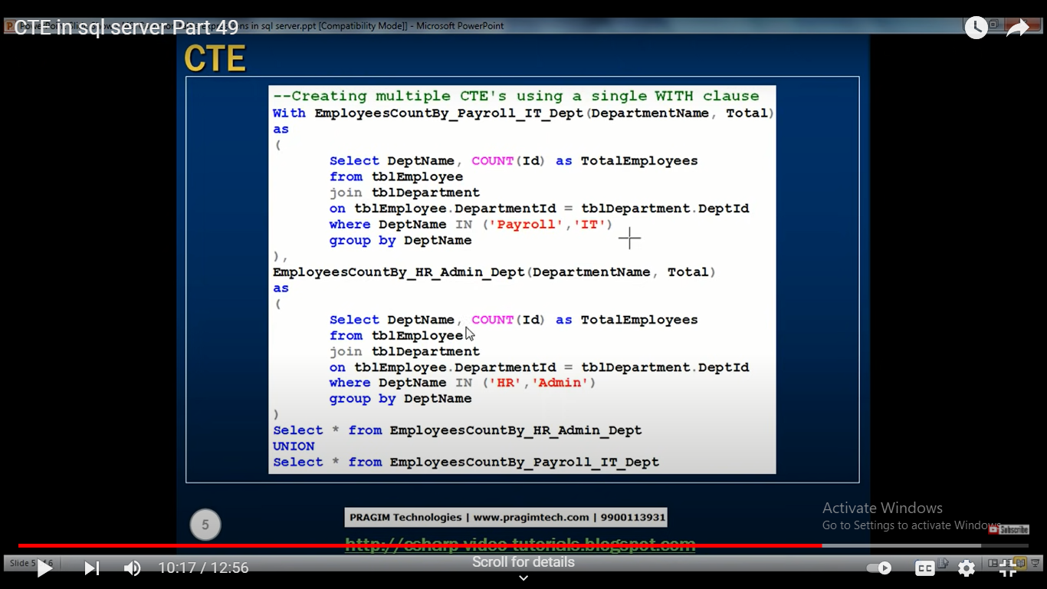

**What is wrong with this SQL query ?**

select e_gender, avg(e_age) from employee where avg(e_age)>30 group by e_gender

Whenever you working with aggregate function and we are using crew by we can’t use the where clause so instead of the bad clause you would have to use the having clause

Correct query : select e_gender, avg(e_age) from employee group by e_gender having avg(e_age)>30

**What do you know about stuff?**

Syntax : Stuff(String1, Position, Length, String2)

string1 is basically that string which would be overwritten

position would basically indicate the starting location for overwriting the string

in length is the length of the substitute string

string2 is that string which would overwrite this string

Query : select stuff('SQL Tutorial',1,3,'Python')

Output : Python Tutorial

**What is view ? Give an example.**

A view is a virtual table based on the result set of a SQL statement. A view contains rows and columns, just like a real table. The fields in a view are fields from one or more real tables in the database.

Syntax : create view viewName as query statement

**What is a stored procedure ? give an example**

A stored procedure is a prepared SQL code which can be saved and reused.

Once store and call for several times whenever required. Faster execution when compared to executing multiple queries.

Syntax : create procedure procedureName

As

Query statement

Go

**Explain about different joins.**

A JOIN clause is used to combine records from two or more tables in a database.

Different Joins :

Inner Join : which basically returns records that have matching values in both the tables.

Left Join : Left join returns rows which are common between the tables and all rows of the left hand side table notice it returns all the rows from the left hand side table even though there are no matches.

Right Join : In the right join returns rows which are common between the tables and all the rows of the right hand side tables there are it returns all the rows from the right hand side table even though there are no matches in the left hand side of the table .

Full Join : full join returns all matching and not matching records from the both tables.

Cross Join : Cross join is Cartesian. Every record of one table is joined with other table records. Don’t have **On** condition.

**What do you understand about temporary table ?**

Temporary tables are created in tempDB and deleted as soon as the session is terminated.

Help us to store and process the intermediate result.

Syntax : create table #tableName(ColumnName datatype);

**Difference between OLTP and OLAP.**

OLTP basically stands for online transaction processing and you can consider it to be your class of software application capable of supporting transaction oriented program and an important attribute of an OLTP system is its ability to maintain concurrency so LT be system often follow word decentralized architecture to avoid single point of failure and these systems are generally designed for a large audience of end users who conduct short transaction and queries involved in such database are generally simple need fast response times and return relatively few records so the number of transactions per second acts as an effective measure for that systems.

OLAP stands for online analytical processing and it is a class of software programs which are characterized by relatively low frequency of online transactions so queries are often too complex and and involve a bunch of aggregations and for olp systems the effectiveness measure relies highly on response time so such systems are widely used for data mining or maintain aggregated historical data and this is usually used in multi-dimensional schemas.

**What is the difference between delete and truncate ?**

Delete query is used to delete or remove one or more existing tables record.

Delete there is a (DML) Data manipulation command.

Truncate statement deletes all of the data inside the table.

Truncate would be (DDL) data definition language command .

We can’t really execute a trigger in case of truncate while with delete we can accomplish a trigger now also if what table is referenced by any foreign key constraints then truncate won’t work so if you have a foreign key then you’d have to use delete and you wouldn’t be able to use the truncate command.

**Difference between union and union all operators ?**

Union operator is used to combine the result set of two or more select statements.

Both query must returns number of columns and order of columns same.

Union all gives all the records from both the tables including the duplicate but Union returns unique/single records from both the tables.

**What is the use of Intersect operator ?**

Intersect operator helps to combine two select statements and returns only those records which are common to both the select statements.

**How can you copy data of one table into another table?**

Insert into employee_duplicate

Select * from employee

**Difference between temp table and global table.**

* **Table variables** (DECLARE @t TABLE) are visible only to the connection that creates it, and are deleted when the batch or stored procedure ends.
* **Local temporary tables** (CREATE TABLE #t) are visible only to the connection that creates it, and are deleted when the connection is closed.
* **Global temporary tables** (CREATE TABLE ##t) are visible to everyone, and are deleted when all connections that have referenced them have closed.
* **Tempdb permanent tables** (USE tempdb CREATE TABLE t) are visible to everyone, and are deleted when the server is restarted.

**Difference between function and procedure.**

| **Sr. No.** | **Key** | **Function** | **Procedure** |
| --- | --- | --- | --- |
| 1 | Definition | A function is used to calculate result using given inputs. | A procedure is used to perform certain task in order. |
| 2 | Call | A function can be called by a procedure. | A procedure cannot be called by a function. |
| 3 | DML | DML statments cannot be executed within a function. | DML statements can be executed within a procedure. |
| 4 | SQL, Query | A function can be called within a query. | A procedure cannot be called within a query. |
| 5 | SQL, Call | Whenever a function is called, it is first compiled before being called. | A procedure is compiled once and can be called multiple times without being compiled. |
| 6 | SQL, Return | A function returns a value and control to calling function or code. | A procedure returns the control but not any value to calling function or code. |
| 7 | try-catch | A function has no support for try-catch | A procedure has support for try-catch blocks. |
| 8 | SELECT | A select statement can have a function call. | A select statemnt can't have a procedure call. |
| 9 | Explicit Transaction Handling | A function can not have explicit transaction handling. | A procedure can use explicit transaction handling. |

**Indexes :**

Increase performance of search records, contains nodes and leaf nodes, contain data in B-tree- balance tree structure format.

In clustered index leaf node will point to actual data. While in case of non-clustered index leaf node takes help of clustered index.

Indexes are used to retrieve data from the database more quickly than otherwise. The users cannot see the indexes, they are just used to speed up searches/queries.

**Note:** Updating a table with indexes takes more time than updating a table without (because the indexes also need an update). So, only create indexes on columns that will be frequently searched against.

Syntax : CREATE INDEX index_name  
ON table_name (column1, column2, ...);

DROP INDEX table_name.index_name;

**clustered index :**

A clustered index defines the order in which data is physically stored in a table. Table data can be sorted in only way, therefore, there can be only one clustered index per table. In SQL Server, the primary key constraint automatically creates a clustered index on that particular column.

The following query retrieves the indexes created on student table.

EXECUTE sp_helpindex student

This clustered index stores the record in the student table in the ascending order of the “id”.

Creating Custom Clustered Index

You can create your own custom index as well the default clustered index. To create a new clustered index on a table you first have to delete the previous index.

CREATE CLUSTERED INDEX IX_tblStudent_Gender_Score

ON student(gender ASC, total_score DESC)

## Non-Clustered Indexes

A non-clustered index doesn’t sort the physical data inside the table. In fact, a non-clustered index is stored at one place and table data is stored in another place. This is similar to a textbook where the book content is located in one place and the index is located in another. This allows for more than one non-clustered index per table.

When a query is issued against a column on which the index is created, the database will first go to the index and look for the address of the corresponding row in the table. It will then go to that row address and fetch other column values. It is due to this additional step that non-clustered indexes are slower than clustered indexes.

CREATE NONCLUSTERED INDEX IX_tblStudent_Name

ON student(name ASC)

From the discussion we find following differences between clustered and non-clustered indexes.

1. There can be only one clustered index per table. However, you can create multiple non-clustered indexes on a single table.
2. Clustered indexes only sort tables. Therefore, they do not consume extra storage. Non-clustered indexes are stored in a separate place from the actual table claiming more storage space.
3. Clustered indexes are faster than non-clustered indexes since they don’t involve any extra lookup step.

--@@@@@@@@@@@@@@@@@@@@@

Ienumerable and iquerable  
First and firstorDefault  
Single and singleordefault  
----------  
keep() - only keep data  
peek() - read and keep data  
**The Keep function is used to preserve the data of TempData object even after the value is read while the Peek function is used to read the value without clearing it**. When value is read from the TempData object, the value is cleared and NULL value is assigned. TempData object value was read in View and hence it is NULL.  
E.g - Viewbag.tdata=tempdata["data"];  
tempdata["data"].keep() ;

Viewbag.tdata=tempdata.peek("data") ;  
-----------  
SOAP uses only XML for exchanging information in its message format whereas REST is not restricted to XML and it's the choice of implementer which Media-Type to use like XML, JSON, Plain-Text. Moreover REST can use SOAP protocol but SOAP can not use REST.  
-------------  
Collection : C# includes specialized classes that store series of values or object are called collections.

Generic : A Generic collection is strongly typed (you can store one type of object into it) so that we can eliminate runtime type mistakes, it improves the performance by avoiding boxing and unboxing.  
Namespace : system.collections.Generic  
List<T>, Dictionary<TKey, TValue>, SortedList<TKey, TValue>,Queue<T>, Stack<T>, Hashtable<T>,

Non-Generic collections :  
Namespace : System.collections;  
Stack, Queue, LinkedList, SortedList, ArrayList, Hashtable.  
ArrayList benefits : size auto resizing, you can insert items in the middle, you can remove item from the middle - above are drawbacks of Array.  
Hashtable : stores data in key/value pair. But in hashtable we can give own key. also cantain add method like ArrayList but hashtable takes two parameters (obj. key and value).  
-------------  
Anonymous Method : A method without method a name, only contain body called Anonymous method. Method is defined using a delegate keyword. Advantage : Lesser code to write. Use only code volumes are low.

delegate int MathOp(int a, int b);

class Program

{

//delegate for representing anonymous method

delegate int del(int x, int y);

static void Main(string[] args)

{

//anonymous method using delegate keyword

del d1 = delegate(int x, int y) { return x * y; };

int z1 = d1(2, 3);

Console.WriteLine(z1);

}

}

//output:

6

-----------------  
Ajax call parameters  
url - compulsory parameter,  
type : get/post,  
data : which you need to send to server, datatype: Json/xml in which format you want data,  
success : function (response) {},  
Error : {}  
---------------  
**SOLID design principal – C#**

SOLID is basically 5 principles, which will help to create a good software architecture. All design patterns are based on these principles. SOLID is basically an acronym of the following :

S - single responsibility principle

O - open closed principle

L - Liskov substitution principle

I - Interface segregation principle

D – Dependency Injection principle

**Single responsibility principle** – A class should take one responsibility and there should be one reason to change that class.

**Open Closed principle** – A class should be open for extension but closed for any modification.

**Liskov substitution principle** – Child class should not break parent class’s type definition and behavior.

**Interface segregation principle** – This principle states that any client should not be forced to use an interface which is irrelevant to it.

**Dependency injection principle** – This principle tells not to write any tightly coupled code because it becomes so hard to maintain when the application is growing bigger and bigger. If a class depends on another class, then we need to change one class if something changes in that dependent class. We should always try to write loosely coupled class.

There are 3 types to Dependency injection

1.Constructor injection

2.Property injection

3.Method injection

For examples – SOLID principle - Watch video - G:\Study Material\C#\Solid Principles C# _ Interview Question Answer.mp4

-----------  
Pagination in LINQ - skip() and Take() function  
EntityState in Entity Framework : 1.Added, 2.Modified 3.Deleted 4.Unchanged 5.Detached  
-------------  
Seed in entity framework  
The seed method takes the database context object as an input parameter, and the code in the method uses that object to add new entities to the database. To seed data into your database, you need to override the seed method.  
-----------  
Eager loading : use for access small data.  
eager loading initializes Or loads a resource as soon as the code is executed.  
Lazy loading :  
Means delaying the loading of related data, until you specifically request for it.  
Use for access huge data.  
---------  
Depending injection  
Action methods  
Routing  
CTE - sql  
Ref and out in c#  
Dispose and Finalize diff.  
Entity state - entity framework  
Hashtable, dictionary - c#  
Rest and restful - web api  
Trigger, also check syntax  
Cursor, also check syntax  
How to register shared Assembly  
How maintain version in MVC app and web api  
If you want to insert thousands of records at a time which you prefer to use and which is faster tempTable Or CTE and why?  
Constructor types  
Difference between SOAP and rest in api  
Unit testing  
Scopes in javascript  
Arrays in javascript  
Dependancy injection in dot net

--@@@@@@@@@@@@@@@@@@@@@

HR Round :

### [Tell me something about your daily routine ?](https://jobbuzz.timesjobs.com/interview/question/150644/directcommission-sales-interview-questions-ienergizer-ltd-customer-care-executive-associate-voice-tell-me-something-about-your-daily-routine)

1. I usually wake up at 5 o’clock. Then, I brush my teeth and wash my face.
2. After that, I go out for a walk. I come back after an hour and take a bath/a shower.
3. After doing my morning duties, I get dressed and comb my hair.
4. Then I have my breakfast at around 8.30 o’clock.
5. I leave home at 9 o’clock. I go to work by bike. Once I reach office by 9.30 AM . I check task assigned to me and start working on it.
6. Office hours are mostly spent sitting in front of the computer.
7. At around 1 PM I have my lunch.
8. At 4 PM I go to cafeteria to have afternoon tea .
9. I wrap up my work by 6 PM and leave by 6.10 PM
10. Once I reach home by 6.40 PM, then I spent time with my family.
11. After having tea, I usually make some phone calls and check my messages & emails.
12. Post 9 PM usually relax on my couch and watch Television.
13. I have Dinner by 9.30 PM after Dinner.
14. Finally around 10.30 PM I sleep.

How to handle Exception in MVC

difference between Dispose and Finalize method

candiate key

trigger

authorize

Action filter

Result filter

Exception

solid principal

####**JavaScript**

The main difference between the == and === operator in javascript is that **the == operator does the type conversion of the operands before comparison, whereas the === operator compares the values as well as the data types of the operands**.